GREENING KENYA'S FORESTRY OPERATIONS: SOLAR-BIOGAS HYBRID SYSTEMS FOR TREE NURSERIES, FOREST STATIONS AND COMMUNITY FACILITIES
Benjamin Kinyili
Kenyatta University
Correspondence: Email: kinyilibm@gmail.com Telephone: +254723393737

Abstract
Kenya's forestry operations require reliable electricity for water pumping, lighting, communications, refrigeration and digital monitoring, while staff and community facilities also require cooking heat. This paper evaluates a modular solar photovoltaic (PV)-biogas hybrid architecture using a transparent engineering scenario model and Monte Carlo uncertainty analysis (10,000 simulations per facility archetype). Three illustrative daily-load cases were analysed: an 18 kWh tree nursery, 35 kWh forest station and 55 kWh community facility, paired with useful cooking-heat demands of 30, 60 and 100 MJ/day. At median resource conditions, required PV capacity was 4.6, 9.0 and 14.2 kWp, respectively; the corresponding 5th-95th percentile ranges were approximately 3.4-6.3, 6.6-12.2 and 10.4-19.2 kWp. Nominal 5, 10 and 15 kWp arrays met simulated daily energy requirements in about 65%, 69% and 61% of trials before storage and load-shifting constraints. Median biogas requirements were 2.4, 4.8 and 8.0 m3/day, requiring approximately 69, 138 and 230 kg/day of fresh-feedstock equivalent under the assumed yield distribution. Standardized regression shows that electricity demand is the dominant positive driver of PV size, while solar resource and system performance reduce required capacity. The findings support solar-first electrical service with biogas reserved for cooking and controllable thermal loads, but only where feedstock, water, operator time and digestate use are verified. A phased demonstration protocol is proposed with pre-investment audits, metering, commissioning tests and mixed-effects evaluation. Results are modelled design ranges, not measurements from installed Kenya Forest Service systems.
Keywords: anaerobic digestion; biogas; forestry operations; Kenya; Monte Carlo analysis; solar photovoltaic; tree nursery

1 Introduction
Reliable, affordable and low-emission energy is increasingly treated as a foundation for climate-resilient public services and productive rural economies. Globally, solar photovoltaic (PV) technology has become central to decentralised electrification because it is modular, rapidly deployable and suitable for remote loads, while modern bioenergy can provide dispatchable heat from locally available organic residues (International Energy Agency et al., 2024; International Renewable Energy Agency, 2024). Solar-powered water pumping is particularly relevant to nurseries and other water-dependent operations, although performance depends on correct sizing, solar-resource variability, pump characteristics and demand management (Chandel et al., 2015; Aliyu et al., 2018).
Across sub-Saharan Africa, energy access has expanded, but service reliability and clean cooking remain major constraints. Decentralised mini-grids and stand-alone systems can support productive uses where grid extension is slow or supply is weak, yet their development effects depend on demand, affordability, maintenance and local institutional capacity (Nygaard & Dafrallah, 2019; World Bank, 2019). At the same time, household and institutional reliance on fuelwood and charcoal sustains health, labour and environmental burdens. Biogas can convert manure and other biodegradable wastes into a storable fuel and nutrient-rich digestate, but long-term performance is shaped by feedstock availability, water, operator competence, finance and after-sales support (Bond & Templeton, 2011; Muvhiiwa et al., 2017).
Kenya presents a strong but unfinished clean-energy transition. Renewable sources already dominate national electricity generation, while solar PV is expected to play a larger role in distributed supply; nevertheless, integration, storage, financing and maintenance barriers remain (Energy and Petroleum Regulatory Authority, 2024; Sergi et al., 2020). Clean-cooking access rose from 10% in 2013 to 31% in 2023, meaning that 69% of households still relied on polluting fuels (International Energy Agency, 2025a). The Kenya Bioenergy Strategy 2020-2027 and the Kenya National Cooking Transition Strategy 2024-2028 therefore promote sustainable bioenergy and universal clean-cooking access, while Kenya's Second Nationally Determined Contribution links renewable energy, efficient biomass use and forest protection to national climate action (Government of Kenya, Ministry of Energy, 2020; Government of Kenya, Ministry of Energy and Petroleum, 2024; Government of Kenya, 2025).
Within this national transition, tree nurseries, forest stations and associated community facilities form a distinctive operational niche. They may combine daytime water pumping, lighting, communications, computing, refrigeration and security loads with cooking demand for staff or community activities. Electricity interruptions can delay irrigation during seedling establishment, while diesel backup creates fuel-logistics, price, noise and local-emission burdens. Forestry facilities can therefore serve as demonstration sites for reliable decentralised energy, but installations must be justified by measured demand, lifecycle costs, safety, maintainability and contribution to forestry outcomes rather than by technology visibility alone (International Energy Agency, 2025b; Lee et al., 2021).
Solar PV and anaerobic digestion are complementary rather than interchangeable. PV supplies high-quality daytime electricity that can match pumping and office loads; water can be stored at elevation to reduce battery dependence. Biogas stores chemical energy and is generally most efficient when used directly for cooking or process heat. Electricity generation from small biogas systems introduces conversion losses, gas-cleaning needs and engine maintenance, whereas direct use avoids some of this complexity (Mertins & Wawer, 2022). Digester output also varies with substrate composition, dilution, temperature, retention time and inhibition, so claimed gas yields require site testing and monitoring (Obileke et al., 2025). Digestate may return nutrients to nursery plots, provided pathogen, salinity, nutrient-loading and water-pollution risks are controlled (Intergovernmental Panel on Climate Change, 2019).
Despite supportive policies and established knowledge on PV pumping and biogas, there is limited facility-level evidence for sizing modular solar-biogas systems around the combined electrical and thermal demands of Kenya's forestry operations. This paper addresses that planning gap through four questions: what hybrid capacities are implied by representative forestry-facility loads; how uncertain solar resource, load and gas yield affect sizing; which variables dominate design risk; and what implementation and evaluation protocol can distinguish genuine performance from optimistic projections. The contribution is a reproducible pre-feasibility model, quantitative design ranges and a phased governance framework for site-specific pilots.

2 Materials and Methods

2.1 System boundary and archetypes
The system boundary includes PV modules, charge controller or inverter, battery storage, water pumping and electrical loads; a separate anaerobic digester, gas storage, piping and direct-use biogas appliances; and digestate handling. Three archetypes represent increasing service scale. The nursery case uses 18 kWh/day electricity and 30 MJ/day useful cooking heat; the forest-station case uses 35 kWh/day and 60 MJ/day; and the community-facility case uses 55 kWh/day and 100 MJ/day. These are transparent design scenarios, not audited consumption values.

2.2 Deterministic equations
Required PV capacity was calculated as P = E/(H x PR), where E is daily electricity demand (kWh/day), H is peak-sun-hours (kWh/m2/day expressed as equivalent full-sun hours) and PR is the aggregate performance ratio. The central case used H=5.2 and PR=0.76. Annual energy was estimated as P x H x PR x 365. Battery nominal capacity was calculated as E x A/(DoD x eta), with 0.60 day of autonomy, 80% allowable depth of discharge and 92% battery/inverter efficiency. Pumping should be shifted to daylight and elevated storage used as a low-cost form of storage before batteries are enlarged. This energy-balance approach and the emphasis on matching pump demand to available solar energy are consistent with established PV-water-pumping design literature (Chandel et al., 2015; Aliyu et al., 2018).
Daily biogas volume was calculated as Vg = Q/(LHV x eta_s), where Q is useful thermal demand, biogas lower heating value was 21.5 MJ/m3 and eta_s is stove efficiency. Fresh-feedstock equivalent was Vg/Y, where Y is net gas yield. The central case used eta_s=0.58 and Y=0.035 m3/kg fresh feedstock. Because actual yield depends on volatile solids, substrate, dilution, temperature, retention time and inhibition, this coefficient is a screening assumption that must be replaced by biochemical methane-potential testing or a monitored pilot. The screening emphasis on substrate quality and measured yield is consistent with anaerobic-digestion evidence showing that feedstock and operating conditions govern methane production (Bond & Templeton, 2011; Obileke et al., 2025).

2.3 Uncertainty and statistical analysis
Monte Carlo analysis used 10,000 draws per archetype with a fixed random seed. Peak-sun-hours followed a triangular distribution (minimum 4.0, mode 5.2, maximum 6.0); PR followed a truncated normal distribution (mean 0.76, SD 0.05, limits 0.62-0.88); daily loads followed normal distributions with 15% coefficients of variation and truncation at 50-150% of the mean; stove efficiency followed a triangular distribution (0.50, 0.58, 0.65); and gas yield followed a triangular distribution (0.025, 0.035, 0.050 m3/kg). Outputs are medians and 5th-95th percentile uncertainty intervals.
Standardized multiple linear regression was fitted to simulated PV capacity as a diagnostic sensitivity analysis, using electricity demand, peak-sun-hours and PR as predictors. Coefficients are not causal field estimates; they rank which assumed uncertainties most influence the model. The probability that a nominal 5, 10 or 15 kWp array met the simulated daily-energy sizing requirement was also calculated. Storage dispatch, hourly irradiance and pump-starting current were not modelled, so final design requires hourly simulation and equipment data.

2.4 Evidence and reproducibility
The model structure was checked against official Kenyan energy strategies, EPRA statistics, IEA clean-cooking evidence and IPCC manure-management guidance. All equations, distributions and central values are reported in Table 1. This complete disclosure allows decision makers to substitute site-audit data. The approach is a pre-feasibility analysis and does not claim experimental validation.
Table 1. Model inputs and uncertainty distributions
Parameter | Central value | Uncertainty distribution | Role
Electric load | 18 / 35 / 55 kWh/day | Normal, CV 15%; truncated 50-150% | PV sizing
Useful heat | 30 / 60 / 100 MJ/day | Normal, CV 15%; truncated 50-150% | Biogas sizing
Peak-sun-hours | 5.2 h/day | Triangular 4.0, 5.2, 6.0 | PV yield
Performance ratio | 0.76 | Normal SD 0.05; truncated 0.62-0.88 | System losses
Biogas LHV | 21.5 MJ/m3 | Fixed screening value | Gas energy
Stove efficiency | 0.58 | Triangular 0.50, 0.58, 0.65 | Useful heat
Fresh-feedstock gas yield | 0.035 m3/kg | Triangular 0.025, 0.035, 0.050 | Feedstock requirement
Monte Carlo trials | 10,000/archetype | Fixed seed | Uncertainty estimation

3 Results

3.1 Deterministic system sizing
Table 2 presents central-case results. PV requirements scale almost linearly with electricity demand: 4.56 kWp for the nursery, 8.86 kWp for the station and 13.92 kWp for the community facility. Rounding to commercially practical blocks gives 5, 10 and 15 kWp. With 0.60 day of autonomy, calculated nominal battery capacities are 14.7, 28.5 and 44.8 kWh. These storage values should be treated as ceilings for initial procurement because daylight pumping, gravity storage, efficient appliances and operational scheduling can reduce electrochemical storage requirements.
The heat model produces central biogas demands of 2.41, 4.81 and 8.02 m3/day. At 0.035 m3/kg net gas yield, feedstock requirements are 69, 138 and 229 kg/day. Such quantities are feasible only where a daily collection chain exists. A forestry site without livestock, canteen waste or a nearby institutional substrate source should not procure a digester merely because solar PV is viable.

3.2 Uncertainty results
The simulated distributions are right-skewed because poor solar resource and low PR jointly increase required capacity. Median PV requirements were about 4.6, 9.0 and 14.2 kWp. Across the central 90% of trials, the ranges were approximately 3.4-6.3, 6.6-12.2 and 10.4-19.2 kWp. Thus, a nominal system sized only at the central estimate will fail the daily-energy screen in a material fraction of plausible conditions. The nominal 5, 10 and 15 kWp options met the simplified requirement in roughly two-thirds of simulations; reliability targets above 90% require either oversizing, measured resource/load data, demand flexibility or supplementary supply. Table 3 reports these uncertainty intervals and adequacy probabilities, while Figure 1 compares the resulting PV-capacity and feedstock distributions across the three facility archetypes.
Biogas feedstock uncertainty was wider in proportional terms because it compounds variation in heat demand, appliance efficiency and gas yield. Median requirements were approximately 69, 138 and 230 kg/day, with 5th-95th percentile ranges reported in Table 3. Metered gas production and feedstock mass during a pilot are therefore more informative than digester nameplate volume.

3.3 Sensitivity
Standardized regression identified daily demand as the strongest positive driver of PV capacity, followed by negative effects of solar resource and PR. Figure 2 visualises the forest-station coefficients, and Table 4 reports the corresponding standardized coefficients for all three archetypes. The result prioritizes inexpensive measurement: a four-week load audit and pump-efficiency test can reduce sizing uncertainty before procurement.

Table 2. Central-case hybrid sizing results
Facility | PV required | Nominal PV | Nominal battery | Biogas | Feedstock | Wood equivalent avoided*
Tree nursery | 4.55 kWp | 5 kWp | 14.7 kWh | 2.41 m3/day | 69 kg/day | 4.9 t/year
Forest station | 8.86 kWp | 10 kWp | 28.5 kWh | 4.81 m3/day | 137 kg/day | 9.7 t/year
Community facility | 13.92 kWp | 15 kWp | 44.8 kWh | 8.02 m3/day | 229 kg/day | 16.2 t/year
*Wood-equivalent displacement uses 15 MJ/kg fuelwood and 15% useful efficiency; it is an energy equivalence, not a measured reduction in harvesting.

Table 3. Monte Carlo uncertainty results (10,000 trials per archetype)
Facility | PV median (P5-P95) | Nominal PV adequacy | Gas median (P5-P95) | Feedstock median (P5-P95)
Tree nursery | 4.7 (3.4-6.2) kWp | 64.3% | 2.4 (1.8-3.1) m3/day | 66 (46-94) kg/day
Forest station | 9.0 (6.5-12.1) kWp | 71.0% | 4.8 (3.6-6.2) m3/day | 133 (93-187) kg/day
Community facility | 14.3 (10.3-19.1) kWp | 60.9% | 8.1 (6.0-10.3) m3/day | 221 (154-313) kg/day
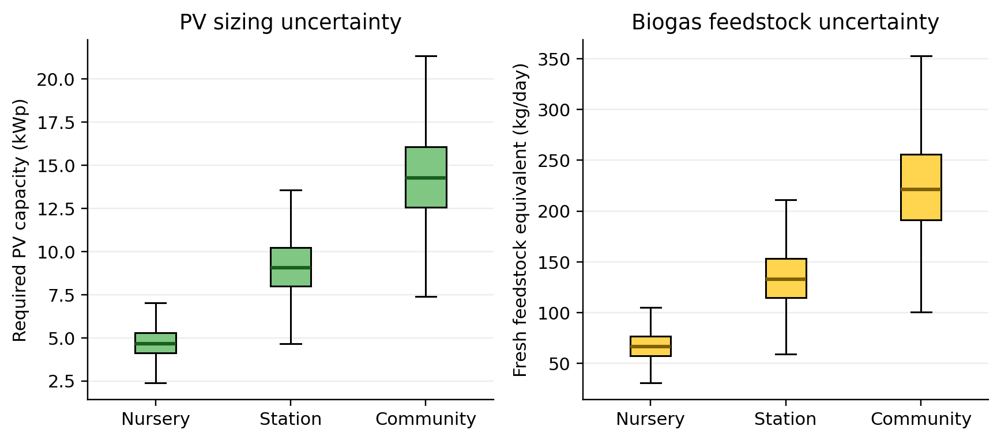
Figure 1. Simulated PV-capacity and feedstock distributions. Boxes show interquartile ranges; whiskers use the conventional 1.5-IQR rule; outliers are suppressed for legibility.
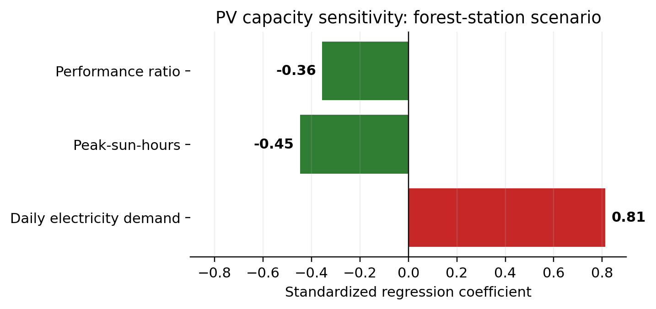
Figure 2. Standardized regression sensitivity coefficients for required PV capacity in the forest-station scenario. Magnitudes rank influence within the stated distributions.
Table 4. Standardized sensitivity coefficients for PV sizing
Facility | Electricity demand | Peak-sun-hours | Performance ratio | Adjusted R2
Tree nursery | 0.804 | -0.445 | -0.354 | 0.986
Forest station | 0.813 | -0.448 | -0.356 | 0.986
Community facility | 0.809 | -0.447 | -0.354 | 0.986

4 Discussion

4.1 Solar-first electrical architecture
The model supports a solar-first architecture for forestry electricity. Water pumping is naturally shiftable and can be coupled to elevated tanks, reducing both battery capacity and cycling. Critical night loads should be separated from flexible loads on dedicated circuits. A modest battery can then support communications, security lighting, controls and refrigeration, while non-critical pumping is inhibited during low state of charge. Remote monitoring should record PV production, load, battery state of charge, pump runtime and water delivered. This load-matching principle reflects the wider evidence that solar pumping performs best when system sizing and operational scheduling are treated together (Chandel et al., 2015; Aliyu et al., 2018).
PV capacity should not be selected from average solar resource alone. The uncertainty analysis shows that resource, PR and demand interact. Dust, shading, high module temperature, cable losses and inverter clipping reduce output; pump starting currents and seasonal irrigation can create short peaks not represented by daily totals. Procurement specifications should therefore require an hourly energy balance, shading survey, surge assessment, earthing, lightning protection, safe battery enclosure and locally serviceable components.

4.2 Biogas viability as a feedstock question
Biogas viability is determined primarily by reliable substrate rather than digester volume. The central forest-station case requires roughly 138 kg/day fresh-feedstock equivalent. Sites should weigh and characterize available manure and organic residues for at least 28 consecutive days spanning operational variability. Water for mixing, labour for feeding, slurry handling and land for safe digestate use must be included. Woody residues are generally unsuitable for simple wet digesters because lignin is poorly degradable; nursery weeds or leaves cannot be assumed equivalent to manure or food waste. Comparable implementation studies identify capital, knowledge, feedstock and operational support as persistent adoption constraints (Muvhiiwa et al., 2017; Lee et al., 2021).
Direct thermal use avoids the poor economics and maintenance intensity of very small biogas generators. Gas appliances require flame-failure protection, ventilation, pressure regulation, condensate traps and leak testing. Hydrogen sulphide control may be necessary. Digestate should be managed as a nutrient product only after agronomic and hygiene assessment; uncontrolled discharge would transfer pollution from air to water. The preference for direct thermal use at small scale is also supported by reviews showing that utilisation pathways must be matched to gas volume, cleaning requirements, heat demand and business model (Mertins & Wawer, 2022).

4.3 Interpreting national relevance
The IEA's 2023 clean-cooking statistic—31% access, with 69% still relying on polluting fuels—shows the scale of the thermal-energy challenge. Forestry-community facilities can demonstrate alternatives, yet they should not be treated as substitutes for national access programmes. Likewise, Kenya's already high renewable share in electricity generation means carbon claims from displacing grid electricity may be modest and time-dependent. The stronger operational case is service reliability, avoided diesel use at off-grid or weak-grid sites, and reduced pressure on fuelwood where biogas replaces unsustainably harvested biomass.
The indicative map in Figure 3 emphasizes contextual selection. High-solar arid sites may have excellent PV yield but limited water and digestible feedstock. Humid and peri-urban sites may have more feedstock but higher cloud variability or stronger grid alternatives. Pilots should deliberately span these contrasts rather than replicate one design nationally.

4.4 Economic and institutional safeguards
A credible business case should use life-cycle cost rather than capital cost alone. It must include battery replacement, inverter replacement, digester desludging, gas-appliance maintenance, operator time, metering, insurance and safe end-of-life handling. Benefits should include water delivered, seedling losses avoided, diesel or purchased fuel displaced, staff time saved and digestate value only when documented. Sensitivity to discount rate, equipment life and fuel price should be reported rather than hidden in a single payback period.
Ownership must be explicit. Kenya Forest Service or the host institution should retain asset registers and safety responsibility; a trained operator should hold daily checklists; service providers should have response-time obligations; and community committees should not be assigned technical liability without authority and resources. Ring-fenced maintenance funds are essential because a failed battery or gas valve can disable an otherwise sound installation.
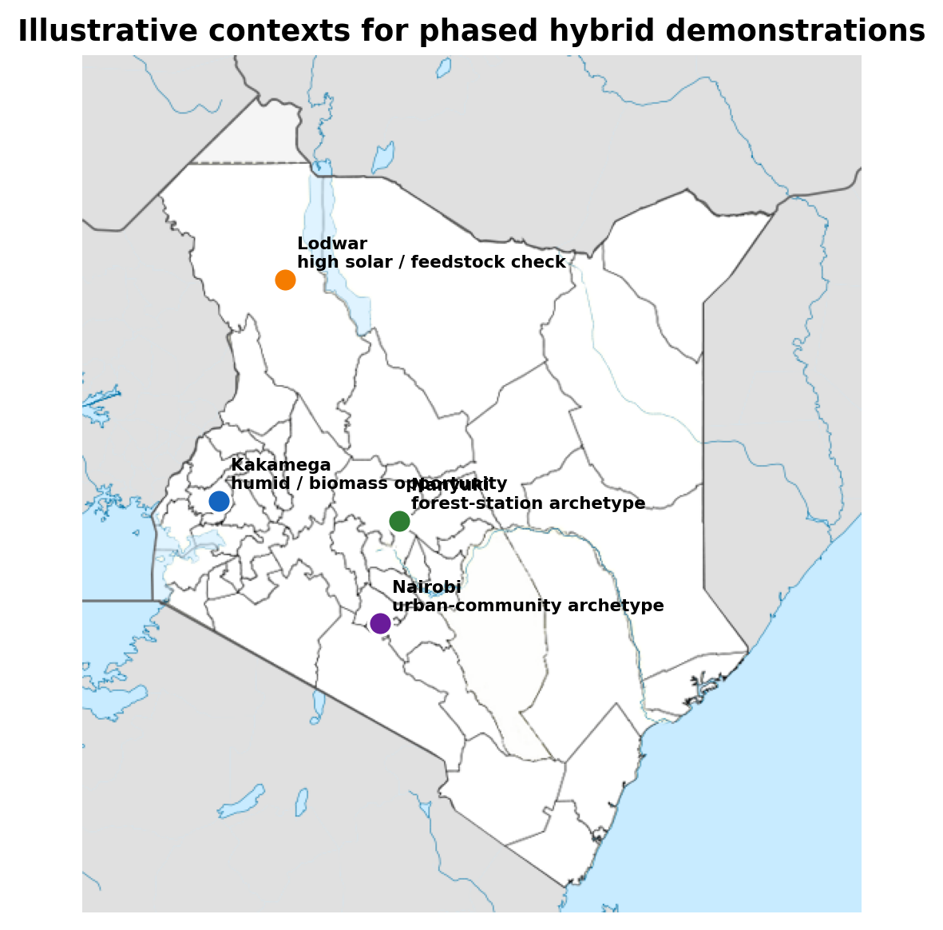
Figure 3. Illustrative contexts for a deliberately heterogeneous demonstration portfolio. Points identify example contexts, not selected or approved project sites. Base map: Wikimedia Commons, Kenya location map Copy.png, CC BY-SA.

5 Phased Demonstration and Evaluation Protocol
Phase 0 is a no-build audit: 28 days of 15-minute electricity logging, pump flow and head measurement, cooking-energy measurement, daily feedstock weighing, water availability, land and safeguard screening. Sites failing the feedstock test may proceed with PV alone. Phase 1 installs one instrumented system per contrasting context with conservative loads and modular expansion. Commissioning verifies insulation resistance, protection settings, battery usable capacity, pump output, digester leak-tightness, gas quality and appliance safety.
Phase 2 evaluates performance for 12 months across wet and dry seasons. Primary electrical outcomes are renewable fraction, loss-of-load hours, kWh generated, battery throughput, water delivered per kWh and downtime. Thermal outcomes are gas yield per kilogram of volatile solids or fresh feedstock, useful cooking events, fuelwood or LPG displaced, digester temperature and maintenance hours. Social outcomes include operator workload by gender, user satisfaction, safety incidents, payment or governance performance and distribution of benefits.
Where several sites are available, evaluation should use a stepped-wedge or matched comparison design. Monthly outcomes can be analysed with mixed-effects models containing intervention status, season and facility type as fixed effects and site as a random intercept. Pre-specified minimum success criteria could include at least 95% critical-load availability, at least 85% scheduled pumping completion, no major safety event, biogas yield within 20% of the design value for three consecutive months, and maintenance response within the contracted period. Confidence intervals and downtime distributions should accompany averages.
Scale-up should occur only after a gate review. A solar-only system may scale even when digestion fails; this modular decision rule prevents the weaker subsystem from undermining the stronger one. Conversely, a feedstock-rich institution may expand thermal biogas while retaining grid or solar electricity. Standardized data dictionaries and dashboards can support cross-site learning without forcing identical hardware.

6 Conclusions and Recommendations
Solar-biogas hybrids can support greener forestry operations, but a hybrid label is not itself evidence of integration or value. The model indicates practical PV blocks of roughly 5, 10 and 15 kWp for the three illustrative archetypes, with median biogas needs of 2.4, 4.8 and 8.0 m3/day. Uncertainty ranges are wide enough that audited data are necessary before tendering. The feedstock requirement approximately 69, 138 and 230 kg/day at median assumptions—is the critical go/no-go test for digestion.
Five recommendations follow. First, meter loads and weigh feedstock before design. Second, use PV for electricity and direct biogas for thermal loads unless a surplus-gas case for generation is demonstrated. Third, prioritize daylight pumping, water storage and efficient appliances before adding batteries. Fourth, procure multi-year service, safety and replacement provisions with every installation. Fifth, evaluate pilots with pre-specified quantitative outcomes and mixed-effects or matched designs across seasons. These steps can turn forestry facilities into credible demonstration sites while avoiding stranded digesters, undersized arrays and unmaintained batteries.

Declarations
Funding: No external funding was received for this study.
Competing interests: The author declares no competing interests.
Ethics approval: Not applicable; no human participants or animals were involved.
Data availability: No primary field dataset was generated. Model equations, distributions and central assumptions are reported in the paper; simulated outputs were generated with a fixed random seed.
Author contribution: Benjamin Kinyili conceived the study, developed the model, interpreted the results and prepared the manuscript.

References
Aliyu, M., Hassan, G., Said, S. A., Siddiqui, M. U., Alawami, A. T., & Elamin, I. M. (2018). A review of solar-powered water pumping systems. Renewable and Sustainable Energy Reviews, 87, 61-76. https://doi.org/10.1016/j.rser.2018.02.010
Bond, T., & Templeton, M. R. (2011). History and future of domestic biogas plants in the developing world. Energy for Sustainable Development, 15(4), 347-354. https://doi.org/10.1016/j.esd.2011.09.003
Chandel, S. S., Naik, M. N., & Chandel, R. (2015). Review of solar photovoltaic water pumping system technology for irrigation and community drinking water supplies. Renewable and Sustainable Energy Reviews, 49, 1084-1099. https://doi.org/10.1016/j.rser.2015.04.083
Energy and Petroleum Regulatory Authority. (2024). Energy and petroleum statistics report for the financial year 2023/2024. EPRA.
Government of Kenya. (2025). Kenya's second nationally determined contribution, 2031-2035. https://unfccc.int/NDCREG
Government of Kenya, Ministry of Energy. (2020). Kenya bioenergy strategy 2020-2027. Ministry of Energy.
Government of Kenya, Ministry of Energy and Petroleum. (2024). Kenya national cooking transition strategy 2024-2028. Ministry of Energy and Petroleum.
International Energy Agency. (2025a). Universal access to clean cooking in Africa. IEA. https://www.iea.org/reports/universal-access-to-clean-cooking-in-africa
International Energy Agency. (2025b). Kenya 2024: Energy policy review. IEA. https://www.iea.org/reports/kenya-2024
International Energy Agency, International Renewable Energy Agency, United Nations Statistics Division, World Bank, & World Health Organization. (2024). Tracking SDG 7: The energy progress report 2024. World Bank. https://trackingsdg7.esmap.org/
International Organization for Standardization. (2016). ISO 13065:2015 sustainability criteria for bioenergy. ISO.
International Renewable Energy Agency. (2016). Solar pumping for irrigation: Improving livelihoods and sustainability. IRENA.
International Renewable Energy Agency. (2024). Renewable capacity statistics 2024. IRENA. https://www.irena.org/Publications/2024/Mar/Renewable-capacity-statistics-2024
Intergovernmental Panel on Climate Change. (2019). 2019 refinement to the 2006 IPCC guidelines for national greenhouse gas inventories: Volume 4, Chapter 10 - Emissions from livestock and manure management. IPCC.
Lee, C.-J., Shirley, R., Otieno, M., & Nyambura, H. (2021). Powering jobs: The employment footprint of clean cooking solutions in Kenya. Energy, Sustainability and Society, 11, Article 27. https://doi.org/10.1186/s13705-021-00299-0
Mertins, A., & Wawer, T. (2022). How to use biogas? A systematic review of biogas utilization pathways and business models. Bioresources and Bioprocessing, 9, Article 59. https://doi.org/10.1186/s40643-022-00545-z
Muvhiiwa, R., Hildebrandt, D., Chimwani, N., Ngubevana, L., & Matambo, T. (2017). The impact and challenges of sustainable biogas implementation: Moving towards a bio-based economy. Energy, Sustainability and Society, 7, Article 20. https://doi.org/10.1186/s13705-017-0122-3
Nygaard, I., & Dafrallah, T. (2019). The impact of an electrical mini-grid on the development of a rural community in Kenya. Energies, 12(5), Article 778. https://doi.org/10.3390/en12050778
Obileke, K., Makaka, G., Tangwe, S., & Okwu, M. O. (2025). Improvement of biogas yields in an anaerobic digestion process via optimization technique. Environment, Development and Sustainability, 27, 15025-15051. https://doi.org/10.1007/s10668-024-04540-6
Sergi, B., Babcock, M., Williams, N. J., Thornburg, J., Loew, A., & Ciez, R. E. (2020). Barriers and solutions for increasing the integration of solar photovoltaic in Kenya's electricity mix. Energies, 13(20), Article 5502. https://doi.org/10.3390/en13205502
United Nations Industrial Development Organization. (2021). Biogas technology and its application for sustainable development. UNIDO.
World Bank. (2019). Mini grids for half a billion people: Market outlook and handbook for decision makers. World Bank. https://openknowledge.worldbank.org/handle/10986/31926

