Antibiotic sensitivity of bacterial isolates from farmed fish in Uasin Gishu County, Kenya

Edwin Kipyegon Mutai^{1,2,}*, Moses Mwajar Ngeiywa¹ , David Mbeva Liti¹, Patricia Jepchirchir Kosgei^{1,3}

Department of Biological Sciences, School of Science, University of Eldoret, PO Box 1125-30100, Eldoret, Kenya

Department of Health Sciences, Ollessos National Polytechnic, PO Box 210-30302, Lessos, Kenya

Department of Applied Sciences, Ollessos National Polytechnic, PO Box 210-30302, Lessos, Kenya

ABSTRACT
The study was conducted with the aim of investigating the antibiotic sensitivity of bacterial isolates from farmed fish to commonly used antibiotics in Uasin Gishu County, Kenya, a region experiencing rapid aquaculture growth. Despite no direct antibiotic use in local fish farms, concerns over antimicrobial resistance (AMR) have emerged due to indirect exposure from integrated livestock-crop systems. A longitudinal study design was used to evaluate microbial infestations. Over a 12-month period, 468 fish samples from 13 ponds across five farms were examined, yielding 154 bacterial isolates representing 12 species, including E. coli, Aeromonas spp., Pseudomonas aeruginosa, Vibrio spp., and Flavobacterium columnare. Antibiotic susceptibility testing was conducted using six commonly used antibiotics: amoxicillin (AMX), erythromycin (ERY), cotrimoxazole (CT), doxycycline (DO), streptomycin (STR), and ciprofloxacin (CIP). Statistical analysis using Fisher’s exact test revealed significant interspecies resistance variation for AMX and ERY (p = 0.0005), while the other antibiotics showed consistent susceptibility across species. PCA and heatmap analyses confirmed AMX and ERY as the primary drivers of resistance variation, particularly in E. coli, A. hydrophila, and Streptococcus spp., which showed resistance rates above 35–50%. Conversely, CIP, DO, and STR exhibited high effectiveness, with over 80% susceptibility in most isolates. The results suggest that indirect exposure through runoff, manure application, and effluent from livestock farming is likely promoting resistance. The findings of this study reveal that antibiotic use in surrounding agricultural systems, although not directly applied to fish, may be contributing to the development of resistant bacterial populations within aquaculture environments. This highlights a critical link between terrestrial and aquatic ecosystems, reinforcing the need for a One Health approach to antimicrobial stewardship. The results emphasize the importance of regular monitoring of antibiotic resistance patterns and adopting tailored antibiotic selection based on local data. Furthermore, the study underscores the necessity of improved waste management, enhanced farmer education, and strengthened biosecurity practices to curb the spread of resistant bacteria. Continued surveillance of antibiotic resistance in aquaculture is essential to ensure food safety, safeguard public health, and promote the sustainability of fish farming systems.
Keywords: Antibiotic resistance, Aquaculture, Bacterial isolates, Fish farming, PCA analysis.

1. INTRODUCTION
Fisheries production has undergone a transformative shift with the rapid expansion of aquaculture, one of the world’s fastest-growing food production sectors in recent decades (FAO, 2022; Pradeepkiran, 2019). It has become a vital contributor to global food security, providing an essential protein source to an increasing global human population (Allison, 2011; Edwards et al., 2019; Makori et al., 2017). With the world’s human population projected to reach 10 billion by 2050, global food production must expand by up to 56% to meet demand (Allison, 2011; FAO, 2022).

Uasin Gishu County, located in Kenya’s North Rift region, has seen substantial growth in aquaculture due to government initiatives promoting fish farming (Uasin Gishu Government, 2015). Despite this growth, sustainable aquaculture can be challenged by poor water quality and the prevalence of microbial and parasitic infections, which negatively impact fish health and productivity (Dabi, 2022; de Abreu Reis Ferreira et al., 2022; Zanchett & Oliveira-Filho, 2013). Additionally, antimicrobial resistance (AMR) in aquaculture has emerged as a significant concern due to the misuse of antibiotics, leading to the development of resistant bacterial strains (Dayie et al., 2024; Huavas et al., 2024). The problem of reduced antibiotic sensitivity among bacterial isolates from farmed fish is not limited to Kenya but reflects a broader regional and global concern. Systematic evidence from Asia, based on 749 point-prevalence surveys conducted between 2000 and 2019, indicates that roughly one-third of tested antimicrobial compounds per survey had resistance rates exceeding 50% (P50 approximately 33%) in aquatic food animals (Schar et al., 2021). In Africa, a recent meta-analysis reported multidrug resistance rates of approximately 43.1% for Escherichia coli, 40.3% for Salmonella spp., and 31.3% for Staphylococcus spp. isolated from aquaculture settings (Moffo et al., 2024). Similarly, a study in Kenya found that 86.36% of bacterial isolates from retail Nile tilapia exhibited multidrug resistance, with multiple antibiotic resistance (MAR) indices greater than 0.30 (Mumbo et al., 2023). These findings together demonstrate that antimicrobial resistance in aquaculture is widespread and a matter of both regional and global public health concern.

Antimicrobial resistance in aquaculture has emerged as a major concern due to the excessive use of antibiotics, leading to the development of drug-resistant bacterial strains (Du et al., 2022). There is an urgent need to assess antibiotic sensitivity patterns among fish pathogens to inform responsible use of antibiotics and improve fish health management in the region. The presence of drug-resistant pathogens in fish farming environments threatens both aquaculture sustainability and public health, as these pathogens may be transmitted to humans through the consumption of contaminated fish (Cabello, 2006; Souza et al., 2019).‬ Assessing antibiotic resistance patterns in fish pathogens will inform strategies for responsible antibiotic use, thereby mitigating the risks associated with antimicrobial resistance.

2. MATERIALS AND METHODS

2.1 Study Area
The study was conducted from May 2023 to April 2024 in selected fish farms across five sub-counties in Uasin Gishu County (UG) as shown in Figure 1. Uasin Gishu County, located in the north west of the Great Rift Valley region, lies approximately 330 km northwest of Nairobi. It covers an area of 2,955 km² and characterized by a highland plateau with several perennial rivers and swampy wetlands (Basweti et al., 2009; Petrikova et al., 2024). The region experiences a temperate climate, with annual temperatures ranging between 7°C to 29°C and rainfall between 624.9 mm to and 1560.4 mm per year (Njonge, 2023).

Aquaculture has been expanding in Uasin Gishu in the last decade, with 1,728 operational fish ponds covering 486,000 m², producing approximately 593,000 kg of fish annually (Uasin Gishu Government, 2015). Most farmers practicing fish farming use earthen ponds, liner ponds, and other water reservoirs. Nile tilapia (Oreochromis niloticus) is the predominant species farmed, followed by African catfish (Clarias gariepinus) (Mwangi et al., 2024).

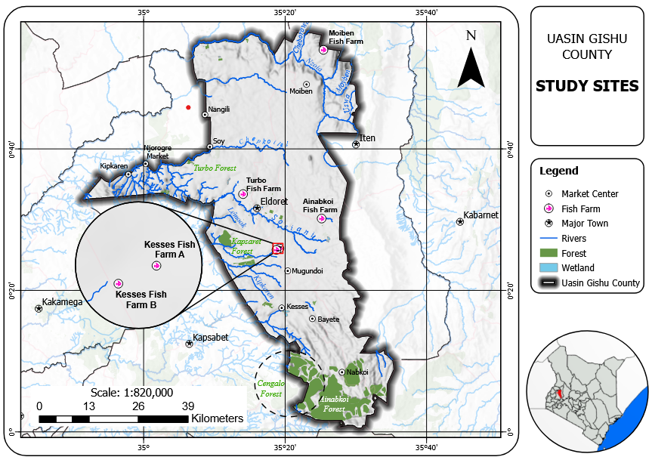
Figure 1. Map of Uasin Gishu showing its location in western Kenya with perennial rivers and swampy wetlands

2.2 Study Sites
Five aquaculture farms were purposively selected based on their features such as; pond type, size, location, inputs (e.g., fertilizers, manure, fish feeds), and duration of operation (minimum of one year) as indicated in Table 1. Each pond in the selected farm site was sampled monthly for 12 months to monitor water quality and fish health.

Table 1: Location and Features of the Selected Fish farms in Uasin Gishu County where the study was carried out
Sub-County | Farm Site Name | Pond | Type of Ponds
Moiben | Moiben Farm (Farm A) | P1 | Raised liner pond
 |  | P2 | Earthen pond
 |  | P3 | Earthen pond
 |  | P4 | Earthen pond
Ainapkoi | Ainapkoi Farm (Farm C) | P1 | Ground liner pond
 |  | P2 | Ground liner pond
 |  | P3 | Earthen pond
Kesses | Kesses Farm 1 (Farm K) | P1 | Raised liner pond
 |  | P2 | Raised liner pond
Kesses | Kesses Farm 2 ( Farm S) | P1 | Earthen pond
 |  | P2 | Earthen pond
Turbo | Turbo Farm (Farm T) | P1 | Ground liner pond
 |  | P2 | Ground liner pond

2.3 Study Design and sample size calculation
A longitudinal study design was used to evaluate the diversity and distribution of bacterial in fish cultured in the selected farms. A stratified random sampling approach was used to ensure representation across pond types, locations, and management practices. Each pond was sampled monthly for water quality assessment and fish health monitoring. A total of 13 fish ponds in five farms across four sub-counties were assessed. The sample size for fish was determined using Thrusfield’s formula (Saville & Wittum, 2004) with a 95% confidence interval and 5% absolute precision.

2.4 Fish Sampling, Microbial Analysis and Parasitological Analysis

2.4.1 Fish Sampling
Fish were collected using seine nets and transported in cool boxes to the laboratory. The condition factor (K) was determined using Froese’s formula (Froese, 2006).

2.4.2 Bacterial Isolation and Identification
Fish tissue samples from the intestine, skin, and gills were collected aseptically and homogenized in 0.1% peptone water. Samples (0.1 mL) were inoculated onto selective media: Rimler Shotts Medium Base agar (Aeromonas spp.), Pseudomonas Base agar (Pseudomonas spp.), Thiosulfate Citrate Bile salts Sucrose (TCBS) agar (Vibrio spp.), Tryptic Soy Agar (TSA), and Brain Heart Infusion (BHI) agar. The inoculated plates were incubated at 37ºC for 24 hours. Pure isolates were characterized using morphological and biochemical tests, including Gram staining, oxidase, catalase, motility, indole, urease and citrate tests. The identification followed Bergey’s manual of bacteriology (John, 1998).

3.4.6 Antimicrobial Susceptibility Testing
The susceptibility of isolates was assessed using the standard disc diffusion method on Mueller-Hinton agar, following CLSI (Clinical and Laboratory Standards Institute) guidelines. Six antibiotics were selected for resistance profiling based on common usage in aquaculture and veterinary settings: Amoxicillin (AMX), Erythromycin (ERY), Cotrimoxazole (CT), Doxycycline (DO), Streptomycin (STR), and Ciprofloxacin (CIP). All discs were purchased from Oxoid Ltd.

Statistical Analysis
Fisher’s exact test was employed to determine whether significant differences existed in resistance patterns among bacterial species for each antibiotic. A significance threshold of p < 0.05 was used. To complement the statistical analysis, Principal Component Analysis (PCA) was used to identify key patterns in antimicrobial resistance. All statistical analyses were conducted using R software 4.4.2 (Pile of Leaves) with p ≤ 0.05 considered statistically significant.

3.0 RESULTS

2.1 Bacterial organisms isolated from selected fish farms
A total of 468 fish samples collected from selected fish farms in Uasin Gishu County were investigated for bacterial characterization over a one-year period, resulting in 154 bacterial colony isolates. The 154 bacterial colony isolates displayed a variety of distinct cultural and biochemical characteristics that enabled for their identification. These isolates were distributed across 12 bacterial species, including both Gram-positive and Gram-negative organisms, each exhibiting unique colony morphology and biochemical properties as shown in Table 2.

Table 2: Summary of Bacterial Isolates Identified from Fish Samples in Uasin Gishu County
Bacterial Species | Gram Reaction | Colony Morphology & Key Biochemical Traits
Gram-Positive Bacteria
Bacillus spp. | Positive | Large, dry, irregular colonies; amoebic-like shape; hemolytic; catalase-positive, spore-forming, motile, starch hydrolysis.
Streptococcus spp. | Positive | Pinpoint, purple, non-hemolytic colonies; chains of cocci; ferments glucose and lactose.
Micrococcus spp. | Positive | Small, yellow colonies; cocci in tetrads/clusters; catalase-positive, oxidase-positive.
Gram-Negative Bacteria
E. coli | Negative | Pink colonies on MacConkey agar (lactose fermenter); catalase-negative, oxidase-negative, glucose fermenter (acid & gas).
P. aeruginosa | Negative | Green pigment on blood agar (pyocyanin); β-hemolysis; oxidase-positive, catalase-positive.
A. hydrophila | Negative | Off-white, circular colonies on BA; β-hemolytic; oxidase-positive, fermentative.
A. caviae | Negative | Similar to A. hydrophila but differentiated by oxidase and glucose fermentation patterns.
A. sobria | Negative | Similar colony morphology and hemolysis as other Aeromonas species; Gram-negative rod.
V. harveyi | Negative | Yellow colonies on TCBS (sucrose fermenter); halophilic; nitrate reduction.
V. alginolyticus | Negative | Yellow colonies on TCBS; sucrose fermenter; H₂S production.
Flav. columnare | Negative | Non-hemolytic, yellow colonies on BA; oxidase-negative, starch hydrolysis.
Plesiomonas spp. | Negative | Small, non-hemolytic colonies; oxidase-positive, Gram-negative rod.

4.4 Antibiotic sensitivity of bacterial isolates from farmed fish to commonly used antibiotics.
The results for antibiotic resistance profiles of twelve (12) bacterial species assessed across six antibiotics: amoxicillin (AMX), ciprofloxacin (CIP), cotrimoxazole (CT), doxycycline (DO), erythromycin (ERY), and streptomycin (STR), are shown in Table 3. Amoxicillin and Erythromycin exhibited highly significant interspecies variability in resistance. Both antibiotics yielded p-values of 0.0005, well below the conventional significance threshold of 0.05. This indicates that susceptibility to these two drugs was not uniform across the bacterial isolates, suggesting species-specific resistance dynamics. In contrast, the remaining four antibiotics; Cotrimoxazole, Doxycycline, Streptomycin, and Ciprofloxacin, did not show statistically significant variation in resistance patterns among the bacterial species. Cotrimoxazole yielded a p-value of 0.3183, Doxycycline 0.3618, Streptomycin 0.7561, and Ciprofloxacin 0.8541. These results suggest that resistance to these antibiotics was relatively consistent across the bacterial isolates examined. Overall, the data point to significant differences in bacterial responses to Amoxicillin and Erythromycin, while resistance to Cotrimoxazole, Doxycycline, Streptomycin, and Ciprofloxacin appeared more uniformly distributed regardless of bacterial species.

Table 3: Significance of interspecies variation in antibiotic resistance among bacterial isolates (p < 0.05)
Antibiotic | p_value | Significance | Significance
Amoxicillin (AMX) | 0.0005 | Significant | ***
Erythromycin (ERY) | 0.0005 | Significant | ***
Cotrimoxazole (CT) | 0.3183 | Not significant | ns
Doxycycline (DO) | 0.3618 | Not significant | ns
Streptomycin (STR) | 0.7561 | Not significant | ns
Ciprofloxacin (CIP) | 0.8541 | Not significant | ns
*** - Highly significant differences in resistance patterns
ns - No significant differences in resistance patterns

The results for antibiotic resistance patterns assessed across six antibiotics are presented in Figure 1. Overall, ciprofloxacin, doxycycline, and streptomycin exhibited the highest efficacy, with susceptibility rates exceeding 80% in most bacterial groups. In contrast, amoxicillin and erythromycin demonstrated reduced effectiveness, with resistance observed in up to 60% of isolates for certain taxa.

Within the Aeromonas genus, A. caviae and A. sobria showed particularly high resistance to amoxicillin, with approximately 45–55% of isolates classified as resistant, while A. hydrophila remained largely susceptible (≥85%) across the antibiotic panel. Moderate resistance to erythromycin was also observed in A. caviae (about 30%) and A. sobria (nearly 35%). In contrast, Bacillus spp. and Micrococcus spp. demonstrated strong susceptibility profiles, with ≥90% of isolates responding to all antibiotics tested, and minimal intermediate responses (typically under 10%).

E. coli exhibited moderate resistance to amoxicillin and erythromycin, with approximately 30–35% of isolates resistant, though susceptibility to ciprofloxacin, doxycycline, and streptomycin remained high (≥70%). Flav. columnare showed near-complete sensitivity to all six antibiotics, with resistance levels below 5%. Similarly, P. aeruginosa demonstrated consistent susceptibility across the board, with >85% of isolates classified as sensitive for each antibiotic.

Notable resistance patterns were seen in Plesiomonas spp. and Streptococcus spp., particularly to amoxicillin and erythromycin, where resistance rates reached 40–50%. However, these genera maintained high susceptibility (≥80%) to ciprofloxacin and doxycycline. The Vibrio species (V. alginolyticus and V. harveyi) showed greater heterogeneity in resistance patterns. V. harveyi, for instance, exhibited resistance in ~30% of isolates to both erythromycin and cotrimoxazole, while V. alginolyticus showed slightly lower resistance at around 20–25% for these antibiotics.

The study revealed that ciprofloxacin, doxycycline, and streptomycin were the most consistently effective antibiotics, with over 80% susceptibility across most bacterial species. In contrast, amoxicillin and erythromycin were the least effective, with resistance rates ranging from 30% to over 50% in several taxa, particularly among Aeromonas, Streptococcus, and Vibrio species. These findings highlight the critical need for targeted antibiotic selection based on species-level resistance patterns to optimize therapeutic outcomes and mitigate resistance development.
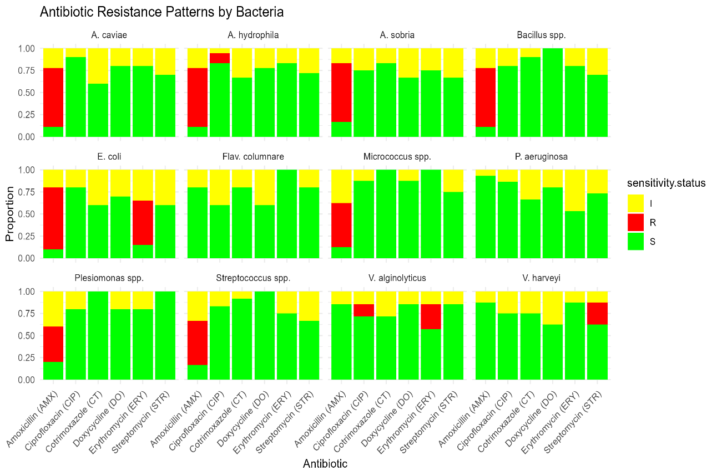
Figure 2. Antibiotic Resistance Patterns of Bacterial Isolates from Fish farms in Uasin Gishu County
Figure 3. illustrates the antibiotic resistance profiles of bacterial isolates using a heatmap with hierarchical clustering. The clustering reveals clear patterns of elevated resistance to Amoxicillin and Erythromycin among several isolates, particularly E. coli, A. hydrophila, and Streptococcus spp., which show strong red signals indicating resistance levels above 60%. In contrast, antibiotics such as Ciprofloxacin, Cotrimoxazole, and Doxycycline showed minimal resistance across all isolates, reflected by the predominance of white or pale pink shading. The dendrogram also groups species with similar resistance behaviors, highlighting the coherence of certain taxa in their antibiotic responses. These visual patterns align with statistical findings from Fisher’s exact test, which confirmed significant interspecies variation only for Amoxicillin and Erythromycin.
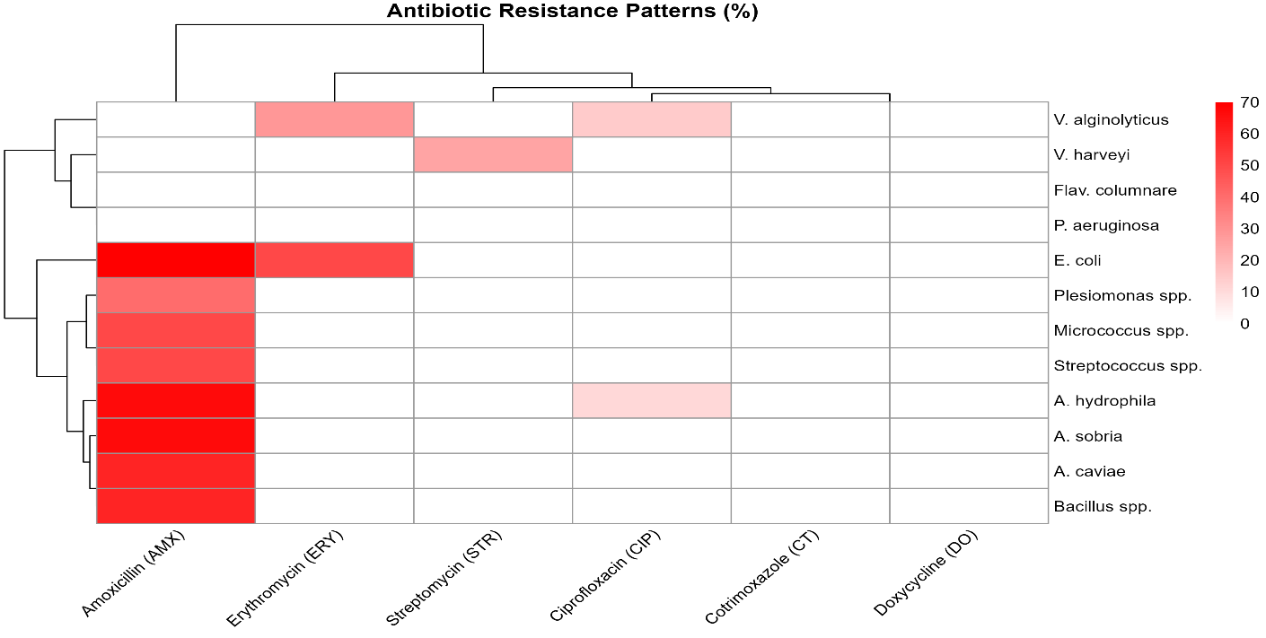Figure 3 Heatmap showing percentage resistance of bacterial isolates to six antibiotics across the fish farms. (The intensity of red color represents the level of resistance, with darker shades indicating higher percentages)

The PCA biplot (Figure 4) summarizes the multidimensional antibiotic resistance data by reducing it into two principal components: Dim1 (37.1% variance) and Dim2 (31.6% variance). Amoxicillin (AMX) and Erythromycin (ERY) project strongly along the positive Y- axis and negative Y-axis respectively, suggesting they are key drivers of resistance variability among the isolates. E. coli and A. hydrophila appear more distant from the origin in relation to these two antibiotics, indicating species-specific resistance trends. In contrast, antibiotics like Ciprofloxacin (CIP), Cotrimoxazole (CT), and Doxycycline (DO), which are less variable according to Fisher’s test, contribute minimally to dimensional separation and cluster near the origin.

The species clusterings further reinforce the heatmap and statistical analysis findings, where isolates with similar resistance responses are grouped together. For instance, V. harveyi and V. alginolyticus lies away from others, indicating distinct resistance behaviors. This PCA visualization supports the interpretation that Amoxicillin and Erythromycin are the most discriminative agents in explaining resistance diversity across the bacterial spectrum.
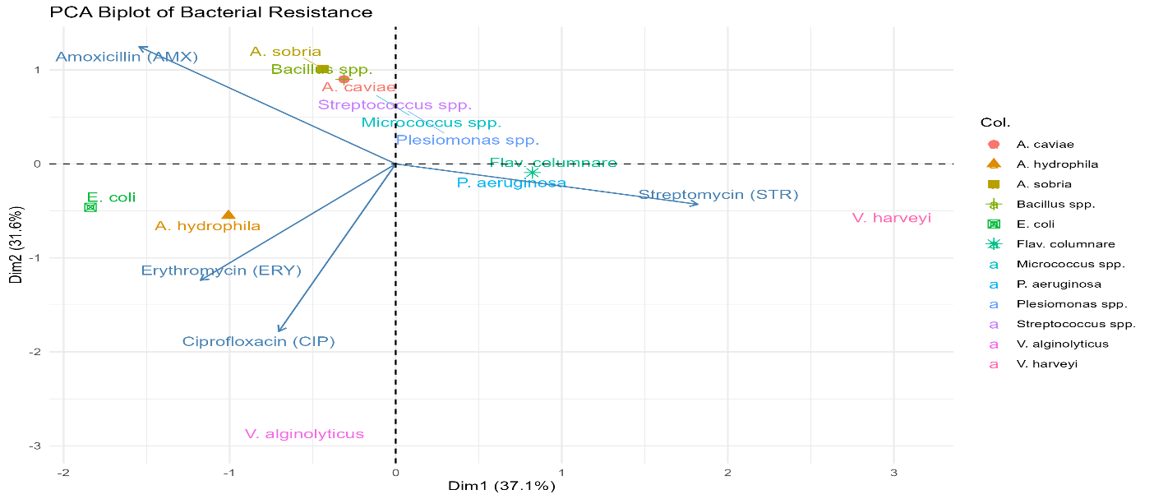Figure 4. Principal Component Analysis (PCA) biplot illustrating variation in bacterial resistance to six antibiotics. (Arrows represent antibiotics, and their directions indicate the contribution to variance along principal components).

3.0 DISCUSSION
The study identified significant interspecies variability in resistance to amoxicillin and erythromycin among bacterial isolates from fish farms in Uasin Gishu County. Fisher’s exact test revealed this variation to be statistically significant (p = 0.0005), emphasizing non-uniform resistance profiles across taxa. Resistance rates exceeded 35–50% in E. coli, A. hydrophila, and Streptococcus spp., as visualized in the heatmap (Figure 2).

This interspecies variability is likely driven by several factors, such as horizontal gene transfer (HGT), which facilitates the spread of resistance genes among environmental bacteria. This process is particularly potent in complex ecosystems like aquaculture, where microbial communities interact within shared water systems. As described by Sun et al. (2025), the persistence and mobility of antibiotic resistance genes (ARGs) in livestock and poultry settings can lead to their accumulation in the environment via effluent, manure, and runoff, eventually reaching aquatic systems through integrated farming practices.

Data from poultry and pig farms also provide compelling parallels. Gudda et al. (2024) documented antibiotic residues in 25.8% of chicken compost samples and 23.1% of pig-manure-fertilized soils, with trimethoprim concentrations exceeding safety thresholds. Resistance risk increased with flock size and antibiotic use intensity, suggesting significant environmental loading of antimicrobials even in terrestrial systems linked to aquaculture via water runoff and integrated farming.

Although no antibiotics are currently used directly for treating fish in the surveyed farms, the integration of fish farming with crop and livestock production introduces potential indirect exposure routes. Antibiotics used in livestock and horticulture can contaminate fishponds via manure fertilization, irrigation runoff, or drainage from nearby fields, thereby exerting selective pressure on aquatic microbiota. This aligns with the “One Health” perspective, emphasizing the interconnectedness of human, animal, and environmental health in driving resistance dynamics (Alhaji et al., 2024).

In contrast, resistance patterns for Cotrimoxazole, Doxycycline, Streptomycin, and Ciprofloxacin showed no statistically significant interspecies variation. These antibiotics exhibited generally low resistance percentages and clustered near the origin in the PCA biplot (Figure 3), suggesting limited contribution to the observed variance in bacterial resistance profiles. This may indicate either conserved bacterial targets or limited environmental exposure to these drugs in the study area. Ciprofloxacin, in particular, demonstrated the highest uniformity, possibly due to its mechanism of targeting essential and highly conserved bacterial enzymes such as DNA gyrase and topoisomerase IV (Rajesh et al., 2025; Vezeau et al., 2025)

The PCA analysis (Figure 3) further clarified relationships among antibiotics and bacterial species. The principal component loading vectors for Amoxicillin and Erythromycin showed strong discriminatory power along the first two dimensions, effectively separating resistant species such as E. coli, A. hydrophila, and V. harveyi from the rest. The clustering of other species near the origin suggests shared susceptibility profiles and minimal variance in resistance to the other tested antibiotics.

These findings underscore the need for enhanced antimicrobial stewardship in aquaculture, even in contexts where antibiotics are not directly applied. Proactive monitoring of environmental exposure routes, integrated with species-specific susceptibility data, is essential for preventing the emergence and dissemination of resistance. Educational outreach to farmers about indirect antibiotic pathways and implementation of biosecurity practices can serve as effective preventative strategies.

4.0 Conclusion
There was significant species-level variation in antibiotic resistance among fish farm bacterial isolates in Uasin Gishu, with highest resistance observed to amoxicillin and erythromycin. The results suggest indirect antibiotic exposure, likely from integrated livestock-crop systems, is driving resistance. In contrast, ciprofloxacin, doxycycline, streptomycin, and cotrimoxazole remained largely effective.

5.0 Recommendation
To address the emerging antibiotic resistance in aquaculture environments, this study recommends enhanced farmer education on indirect exposure pathways, strict waste management practices, responsible antibiotic use across sectors, and further research into resistance mechanisms and environmental transmission routes.

Data Availability Statement
The data that support the findings of this study are available from the corresponding author upon reasonable request.

Acknowledgements
We sincerely thank the University of Eldoret for providing the necessary resources and facilities that enabled us to carry out this study effectively. We are also grateful to the Eldowas Laboratory, Ollessos National Polytechnic, and the Microbiology Technicians for their support and cooperation during the study. Our appreciation extends to the Uasin Gishu County Fisheries Department for their assistance and valuable contributions. We further thank the farmers whose farms were used in this study for their participation and willingness to support our research efforts.

Conflict of Interests
The authors have not declared any conflict of interests.

References
Alhaji, N. B., Odetokun, I. A., Jibrin, M. S., Lawan, M. K., & Kwaga, J. (2024). Antibiotic resistance and mitigation using One Health lens in aquaculture of Northern Nigeria. Journals.Co.ZaNB Alhaji, IA Odetokun, MS Jibrin, MK Lawan, J KwagaOnderstepoort Journal of Veterinary Research, 2024•journals.Co.Za, 91(2), e1–e11. https://doi.org/10.4102/OJVR.V91I2.2165
Allison, E. (2011). Aquaculture, fisheries, poverty and food security. Worldfish.
Basweti, E. A., Turk, P. J., Rayburn, E. B., & Bryan, W. B. (2009). No‐till sequential cropping of summer and fall annual forage species compared with grassland. Wiley Online LibraryEA Basweti, PJ Turk, EB Rayburn, WB BryanAgronomy Journal, 2009•Wiley Online Library, 101(6), 1497–1502. https://doi.org/10.2134/AGRONJ2008.0082X
Cabello, F. . (2006). Heavy use of prophylactic antibiotics in aquaculture: a growing problem for human and animal health and for the environment. Wiley Online LibraryFC CabelloEnvironmental Microbiology, 2006•Wiley Online Library, 8(7), 1137–1144. https://doi.org/10.1111/J.1462-2920.2006.01054.X
Dabi, S. B. (2022). Assessment of Water Quality Parameters for Aquaculture uses: The Case of Guder River, Main Tributaries of Blue Nile, Ethiopia. Sarhad Journal of Agriculture, 38(3), 1060–1068. https://doi.org/10.17582/journal.sja/2022/38.3.1060.1068
Dayie, N. T. K. D., Nathan-Mensah, F. N. N., Kotey, F. C. N., Tabi, B. K. A., Kabotso, D. E. K., Odoom, A., Hotor, P., Dayie, A. D., Tetteh-Quarcoo, P. B., Egyir, B., & Donkor, E. S. (2024). Multidrug-Resistant Bacteria in Aquaculture Systems in Accra, Ghana. Journals.Sagepub.ComNTKD Dayie, FNN Nathan-Mensah, FCN Kotey, BKA Tabi, DEK Kabotso, A Odoom, P HotorEnvironmental Health Insights, 2024•journals.Sagepub.Com, 18, 1–16. https://doi.org/10.1177/11786302241299369
de Abreu Reis Ferreira, D., Assane, I. M., Vaneci-Silva, D., do Vale Oliveira, A., Tamashiro, G. D., Hashimoto, D. T., & Pilarski, F. (2022). Morpho-molecular identification, pathogenicity for Piaractus mesopotamicus, and antimicrobial susceptibility of a virulent Flavobacterium columnare isolated from Nile tilapia cultured in Brazil. Aquaculture, 560. https://doi.org/10.1016/j.aquaculture.2022.738486
Du, Y., Hu, X., Miao, L., & Chen, J. (2022). Current status and development prospects of aquatic vaccines. Frontiersin.Org, 13. https://doi.org/10.3389/FIMMU.2022.1040336/FULL
Edwards, P., Zhang, W., Belton, B., Policy, D. L.-M., & 2019, undefined. (2019). Misunderstandings, myths and mantras in aquaculture: Its contribution to world food supplies has been systematically over reported. ElsevierP Edwards, W Zhang, B Belton, DC LittleMarine Policy, 2019•Elsevier. https://doi.org/10.1016/j.marpol.2019.103547
FAO. (2022). The state of world fisheries and aquaculture... - Google Scholar. Google Scholar. https://scholar.google.com/scholar?hl=en&as_sdt=0%2C5&q=FAO.+%282022%29.+The+state+of+world+fisheries+and+aquaculture+2022%3A+Towards+Blue+Transformation.+%09Food+and+Agriculture+Organization+of+the+United+Nations.&btnG=#d=gs_cit&t=1748898790437&u=%2Fscho
Froese, R. (2006). Cube law, condition factor and weight-length relationships: History, meta-analysis and recommendations. In Journal of Applied Ichthyology (Vol. 22, Issue 4, pp. 241–253). https://doi.org/10.1111/j.1439-0426.2006.00805.x
Gudda, F., Muloi, D., Nganga, F., Nolari, C., Gao, Y., & Moodley, A. (2024). Antibiotic ecotoxicity and resistance risks in resource-constrained chicken and pig farming environments. Nature.ComF Gudda, D Muloi, F Nganga, C Nolari, Y Gao, A Moodleynpj Antimicrobials and Resistance, 2024•nature.Com. https://doi.org/10.1038/s44259-024-00071-2
Huavas, J., Heyse, J., Props, R., Delamare-Deboutteville, J., & Shelley, C. (2024). Microbiomes of Tilapia Culture Systems: Composition, Affecting Factors, and Future Perspectives. Wiley Online LibraryJ Huavas, J Heyse, R Props, J Delamare-Deboutteville, C ShelleyAquaculture Research, 2024•Wiley Online Library, 2024. https://doi.org/10.1155/2024/5511461
John, P. W. M. (1998). Statistical design and analysis of experiments. In Statistical Design and Analysis of Experiments. Society for Industrial and Applied Mathematics. https://doi.org/10.1137/1.9781611971149.BM
Makori, A. J., Abuom, P. O., Kapiyo, R., Anyona, D. N., & Dida, G. O. (2017). Effects of water physico-chemical parameters on tilapia (Oreochromis niloticus) growth in earthen ponds in Teso North Sub-County, Busia County. SpringerAJ Makori, PO Abuom, R Kapiyo, DN Anyona, GO DidaFisheries and Aquatic Sciences, 2017•Springer, 20(1). https://doi.org/10.1186/S41240-017-0075-7
Moffo, F., Ndebé, M. M. F., Tangu, M. N., Noumedem, R. N. G., Awah-Ndukum, J., & Mouiche, M. M. M. (2024). Antimicrobial use, residues and resistance in fish production in Africa: systematic review and meta-analysis. SpringerF Moffo, MMF Ndebé, MN Tangu, RNG Noumedem, J Awah-Ndukum, MMM MouicheBMC Veterinary Research, 2024•Springer, 20(1). https://doi.org/10.1186/S12917-024-04158-W
Mumbo, M. T., Nyaboga, E. N., Kinyua, J., Muge, E. K., Mathenge, S. G. K., Muriira, G., Rotich, H., Njiraini, B., & Njiru, J. M. (2023). Prevalence and antimicrobial resistance profile of bacterial foodborne pathogens in Nile tilapia fish (Oreochromis niloticus) at points of retail sale in Nairobi, Kenya. Frontiers in Antibiotics, 2. https://doi.org/10.3389/FRABI.2023.1156258/FULL
Mwangi, J., Maina, J., Gachuiri, C., … R. W.-E. A. J. of, & 2024, undefined. (2024). Management practices, farmers’ perceptions and coping strategies and challenges to climate change in integrated fish farms in Kenya. Eajsti.OrgJ Mwangi, J Maina, C Gachuiri, R Wahome, R WaruiruEast African Journal of Science, Technology and Innovation, 2024•eajsti.Org, 5(4).
Njonge, T. (2023). Influence of Psychological Well-Being and School Factors on Delinquency , During the Covid-19 Period Among Secondary School Students in Selected Schools in Nakuru County : Kenya. Ir-Library.Ku.Ac.KeGM Nyongesa, G Makokha, S MbuthiaInternational Journal of Research and Innovation in Social Science, 2023•ir-Library.Ku.Ac.Ke, VII(2454), 1175–1189. https://doi.org/10.47772/IJRISS
Petrikova, I., Otieno, M. A., Were, G., Eltholth, M., Mateos, A. R., Harding, S., Moran, V., Osano, O., & Cole, J. (2024). Peri-urban agriculture and household food and nutrition security around Eldoret, Kenya. SpringerI Petrikova, MA Otieno, G Were, M Eltholth, AR Mateos, S Harding, V Moran, O OsanoFood Security, 2024•Springer, 16, 1235–1263. https://doi.org/10.1007/S12571-024-01475-8
Pradeepkiran, J. A. (2019). Aquaculture role in global food security with nutritional value: A review. Translational Animal Science, 3(2), 903–910. https://doi.org/10.1093/tas/txz012
Rajesh, A. M., Subhash Pawar, S., Doriya, K., & Dandela, R. (2025). Combating antibiotic resistance: mechanisms, challenges, and innovative approaches in antibacterial drug development. Explorationpub.ComAM Rajesh, SS Pawar, K Doriya, R DandelaExploration of Drug Science, 2025•explorationpub.Com. https://doi.org/10.37349/eds.2025.100887
Saville, W. J., & Wittum, T. E. (2004). Veterinary Epidemiology. In Equine Internal Medicine: Second Edition (pp. 1513–1528). https://doi.org/10.1016/B0-72-169777-1/50023-8
Schar, D., Zhao, C., Wang, Y., Joakim Larsson, D. G., Gilbert, M., & Van Boeckel, T. P. (2021). Twenty-year trends in antimicrobial resistance from aquaculture and fisheries in Asia. Nature.ComD Schar, C Zhao, Y Wang, DGJ Larsson, M Gilbert, TP Van BoeckelNature Communications, 2021•nature.Com. https://doi.org/10.1038/S41467-021-25655-4
Souza, de M., Caroline, D., Santos, D., Cristina, M., Chagas, & Campos, E. (2019). Immune response of teleost fish to helminth parasite infection. In Revista Brasileira de Parasitologia Veterinaria (Vol. 28, Issue 4, pp. 533–547). https://doi.org/10.1590/s1984-29612019080
Sun, J., Wang, X., He, Y., Han, M., Li, M., Wang, S., Chen, J., Zhang, Q., & Yang, B. (2025). Environmental fate of antibiotic resistance genes in livestock farming. SpringerJ Sun, X Wang, Y He, M Han, M Li, S Wang, J Chen, Q Zhang, B YangArchives of Microbiology, 2025•Springer, 207(5). https://doi.org/10.1007/S00203-025-04320-4
Uasin Gishu Government. (2015). Livestock and Fisheries – County Government of Uasin Gishu. Google Scholar. https://uasingishu.go.ke/index.php/tag/livestock-and-fisheries
Vezeau, N., Diseases, L. K.-G. O. H. and I., & 2025, undefined. (2025). Antimicrobial Resistance–A One Health Issue. Taylorfrancis.ComN Vezeau, LH KahnGlobal One Health and Infectious Diseases, 2025•taylorfrancis.Com, 75–103. https://doi.org/10.1201/9781003232223-6/ANTIMICROBIAL-RESISTANCE-ONE-HEALTH-ISSUE-NEIL-VEZEAU-LAURA-KAHN
Zanchett, G., & Oliveira-Filho, E. C. (2013). Cyanobacteria and cyanotoxins: From impacts on aquatic ecosystems and human health to anticarcinogenic effects. In Toxins (Vol. 5, Issue 10, pp. 1896–1917). https://doi.org/10.3390/toxins5101896

