Development of a Circular Economy Model for The Sustainable Management of End-of-Life Photovoltaic Modules in Kenya.

Kalamazoo Kitheka Ndomboi^{1 *,} Alex Magembe Marucha^{2,} David Wafula Wekesa³

¹Faculty of Science and Technology, Multimedia University of Kenya, kalamazookitheka38@gmail.com
²National Institute for Optics and Lasers, Multimedia University of Kenya, amarucha@mmu.ac.ke,
³Department of Physics, Multimedia University of Kenya, dwekesa@mmu.ac.ke

Abstract
Kenya’s solar photovoltaic sector is expanding rapidly, yet the country lacks an integrated framework for managing end-of-life PV modules with projected waste reaching 42,000 metric tonnes by 2050. The main objective of this study was to develop a circular economy model for the sustainable management of end-of-life solar photovoltaic modules in Kenya, with specific objectives to quantify CO₂ emissions across the lifecycle of solar PV modules, to analyze the identified CO₂ emission profile through the lens of refuse, reduce, and rethink principles linking specific emission drivers to appropriate circular economy interventions, to model and simulate the performance and impacts of different circular economy strategies, and to evaluate the economic viability of the circular economy strategies across lifecycle management scenarios. The study employed a quantitative simulation design using a pragmatist research philosophy and deductive approach, with the target population comprising all monocrystalline silicon PV modules installed in Kenya expected to reach end-of-life between 2030 and 2050, and a purposive sampling technique was used to select a representative 650 Wp monocrystalline silicon module as the sample unit. Data was obtained from lifecycle CO₂ emission values and circular economy intervention parameters derived from Objectives 1 and 2 of the study, and simulation was executed using R and RStudio through five distinct scenarios: Baseline (S0), Refuse (S1), Reduce (S2), Rethink (S3), and combined (S4), with economic viability assessed through net present value, benefit-cost ratio, and discounted payback period calculations. Major findings revealed that manufacturing accounts for 94.68% of lifecycle emissions (222.30 Kg CO₂ –eq per module), the refuse principle achieves the highest single-strategy impact at 23.7% reduction, and the combined scenario delivers the greatest benefit with a 41.7% reduction (97.8 Kg saved per module) translating to 342,449 tonnes of CO₂ avoided nationally by 2050, while combined scenario is also the most economically viable with a positive net present value of USD 34.74 per module, benefit-cost ratio of 2.25, and a discounted payback period of 3 years. The study concludes that Kenya can reduce embodied carbon of its solar expansion by over 40% through circular economy strategies, and recommends for the implementation of green procurement mandates and integration of PV modules into existing e-waste regulations, and long-term investment in local recycling infrastructure and full extended producer responsibility implementation.
Keywords: Circular Economy, End-of-Life Management, Refuse-Reduce-Rethink Principles, Lifecycle CO₂ emissions.
- Introduction
The global landscape is undergoing a radical transformation from carbon-intensive fossil fuels to renewable sources, driven by the Paris Agreement and Sustainable Development Goals [1]. Solar Photovoltaic (PV) systems have emerged as the primary driver of this transition, with global installed capacity exceeding, 1,000 GW and projections indicating solar will account for the majority of new electricity generation by 2050 [2, 3].
However, the environmental narrative of solar energy faces increasing scrutiny through a full life cycle lens. While solar PV generates low-carbon electricity during operation, Upstream and downstream stages – from raw material extraction to end-of-life (EoL) disposal – entail substantial embodied carbon emissions, ranging from 37 to 72 grams CO₂ equivalent per kWh [4]. Without strategic intervention, the renewable energy transition may perpetuate significant carbon footprints, potentially undermining climate objectives [5]. An emerging global challenge is the management of decommissioned solar modules. With a design life of 20-30 years, early installations are entering the waste stream, with cumulative waste estimated at 78 million tonnes by 2050 [6]. These modules contain hazardous materials (lead, Cadmium, antimony) posing ecological risks, yet also hold high-value secondary resources (silver, silicon, aluminum) representing missed economic opportunities if uncovered.
The traditional linear “take-make-dispose” model is increasingly viewed as an inadequate, prompting a global shift toward the Circular Economy (CE) paradigm, which decouples economic growth from resource consumption through closed-loop systems [7]. Within the PV sector, circularity is operationalized through refuse, reduce, and rethink principles which emphasizes on system efficiency, longevity, and redesign for repair, reuse, and recycling [8]. Global leadership centres on the European Union’s WEEE Directive mandating Extended Producer Responsibility (EPR), while major markets like China and the United States continue harmonizing policies, creating regulatory disparities that risk exporting decommissioned modules to developing nations with weaker safeguards [9, 10].
Methodologically, assessment of circular strategies is evolving from static models toward dynamic simulations using Agent-Based Modelling, system Dynamics, and Material Flow Analysis to evaluate strategy combinations and their sensitivity to market conditions [11, 12]. Economic viability remains debated; while landfilling costs $1 – 2 per module, high-value recycling ranges from $20-30, highlighting the need for integrated environmental-economic assessments [13].
In Africa, Solar photovoltaic (PV) adoption is intrinsically linked to socio-economic development and Sustainable Development Goal 7 (Universal energy access). Across Sub-Saharan Africa, off-0grid solar home systems (SHS) and mini-grids have enabled millions to bypass unreliable utility grids. However, this rapid decentralized expansion has occurred with minimal consideration for long-term hardware management. Unlike centralized European projects, Africa’s solar landscape comprises millions of small-scale components dispersed across rural areas, making EoL management logistically complex [14]. The influx of low-quality panels results in accelerated waste generation, while the continent lacks specialized recycling infrastructure. Most decommissioned modules are stockpiled, landfilled, or dismantled informally, leaching heavy metals into soil and groundwater [15]. Yet, recovery of valuable secondary materials could catalyze the growth of new industrial sectors, requiring dynamic, simulation-based models accounting for Africa’s unique constraints.
East Africa has emerged as one of the most vibrant solar PV markets globally, with the Pay-As-You-Go (PAYGO) business model accelerating SHS distribution. However, this success has created shared transboundary e-waste challenges. While the East-African Community has developed an E-Waste Management Strategy, a coordinated framework for high-value PV material recovery remains absent [14]. In Kenya, solar energy has fundamentally transformed the energy landscape, positioning the country as a renewable energy leader in Sub-Saharan Africa. With over 1.3 million solar home systems sold and total installed solar capacity reaching 514.1 MW as of June 2025 [16], Kenya has integrated solar PV technology into vision 2030 and the National Energy Policy (2018), targeting 100% clean energy transition. However, sustainability is threatened by the absence of structured EoL management. Projections indicate Kenya will generate approximately 42,000 metric tonnes of solar PV waste by 2050 as first-generation systems reach functional end-of-life [14]
Waste management is characterized by disparity between policy intent and implementation. While the Sustainable Waste Management Act (2022) and EPR Regulations (2024) provide legal foundations, they lack specific provisions for solar PV module composition. In the absence of formal recycling infrastructure, most EoL modules enter informal sectors or municipal landfills. Economic barriers are stark; Landfilling costs $1-2 versus formal recycling at $20-30 per module [11], incentivizing unsustainable disposal and loss of valuable secondary materials with potential toxic leaching into fragile ecosystems.
Furthermore, the embodied phenomenon represents a critical climate accounting blind spot. As Kenya imports nearly 100% of its PV modules from China, it effectively imports manufacturing carbon footprints. Preliminary findings indicate manufacturing accounts for 94.68% (222.300 Kg CO₂-eq) of total lifecycle emissions for modules deployed in Kenya, with local installation and maintenance contributing negligibly. This confirms that achieving net-zero goals requires moving beyond operational energy generation to address upstream refuse and reduce principles. By developing a localized circular economy model, Kenya can transform solar PV waste from a looming environmental crisis into a climate asset supporting green industrialization and resource security.

2.0 Methodology
The study was structured as a multi-stage quantitative inquiry, integrating Life Cycle Assessment (LCA) standardized by the International Organization for standardization (ISO) 14040/ 14044 protocols with stochastic modeling. The methodology also provides a systematic framework for the quantification of CO₂ emissions, the application of the circular economy interventions to identified hotspots, and the evaluation of regenerative energy trajectories through computational modeling in R-Studio. The design was predicated on the requirement to evaluate non-linear environmental and economic variables over a longitudinal 25-year horizon.
A single representative functional unit of one- 650Wp monocrystalline silicon PV module was used. This unit served as the computational basis for all standardized calculations, which were subsequently scaled to the projected national volume of 3.5 million units by 2050.
A life cycle inventory (LCI) was developed through a sequential three-phase analytical protocol as follows:
Phase 1 (Photovoltaic Module Lifecycle CO₂ emissions Quantification)
System boundary definition: The boundaries were established as cradle-to-grave, encompassing of; manufacturing (A1-A3), transport (A4), Installation (A5), and end-of-life (C1-C4).
Manufacturing stage emissions (A1-A3)
This stage accounts for the embodied emissions associated with raw material production, upstream transportation, and the manufacturing of the entire photovoltaic module. Raw material supply included the extraction and processing of all the materials used, including: crystalline silicon, tampered glass, aluminum frame, EVA/POE encapsulates, Copper ribbons, junction box components, and back-sheet materials. The raw materials were then transported to the manufacturing site through either trucks, rail or road transportation. Manufacturing stage involved processes such as; wafer cutting, solar cell production, module assembly, lamination, testing and packaging of the solar PV modules. Embodied carbon was calculated using a baseline Global Warming Potential (GWP) factor of 0.342KgCO₂-eq/Wp. Manufacturing stage accounted for emissions of up to 222.300 KgCO₂-eq/module (650 Wp).
Transportation stage emissions (A4)
This stage covered the transportation of the manufactured module from the manufacturing country which was assumed to be in China, Jiangxi Province, to the port of Shanghai by road transport using diesel-driven trucks, which was then shipped by sea to the port of Mombasa, and finally transported by road to the installation site at industrial Area in Nairobi, Kenya.
Transportation emissions were calculated using the formula:
E = ∑ (D_{i}×W×EF_{i}) (1)
Where:
D_{i} is the distance covered
W is the mass of the vehicle
EF_{i} is the mode-specific emission factor

Transport stage (A4) contributed approximately 7.011 KgCO₂-eq/module, which is greatly smaller than the manufacturing stage emissions.
Installation stage emissions (A5)
At this stage, the main focus was on the energy used and the fuel consumed during installation. According to the Environmental Product Declaration document for the 650 Wp solar module (Jinko brand):
According to the Kenya Energy and Petroleum Regulatory Authority, the Kenya Grid emission factor is 0.5 t/MWh which is 0.5KgCO₂/kWh.
According to the IPCC defaults, the diesel combustion emission factor is 0.0741 Kg CO₂/MJ.
Emission Calculation:
- Electricity emissions:
$E_{elec}=E×F_{g}$ (2)
where E is the electricity consumed and F_{g} is the Kenyan electricity grid emission factor.
- Diesel emissions:
$E_{diesel}=D×F_{d}$ (3)
Where D is the amount of diesel consumed and F_{d} is the diesel emission factor.
Both the electricity and diesel emissions were summed up and the total emissions related to the installation stage was 0.670 Kg CO₂ eq / Module (650 Wp).
Operation and Maintenance stage emissions (B2)
This stage covered both the planned and unplanned maintenance activities which will be done to ensure the solar PV system is working efficiently and delivering the required power. The energy and material inputs required to maintain functionality and the waste generated during maintenance were assessed in this stage in order to quantify the CO₂ emissions. Activities in this stage included: Periodic cleaning of the modules, Inspection and minor maintenance visits, transport of technicians to and from the site, and occasional water pumping for cleaning the modules.
The total emissions related to the operations and maintenance stage was 4.001 Kg CO₂ eq / Module (650 Wp).
End-of Life stage emissions (C1-C4)
As of 2026, Kenya does not have a fully operational commercial solar PV module recycling plant dedicated exclusively to processing end-of-life PV modules. Traditional e-waste collectors and informal pathways also contribute to material recovery, although these lack formal certification and process consistency.
- Deconstruction and dismantling (C1)
This stage covers all activities required to remove the solar photovoltaic modules from their installed location after being decommissioned. This includes electrical disconnection, unmounting of the modules from support structures, and preparation for transport to waste treatment or disposal facilities. According to EN 15804+A2 and ISO 14044, C1 accounts for emissions arising from energy use, tools, and equipment directly involved in dismantling activities, excluding subsequent transport and processing stages. For the solar system installed at Industrial Area, dismantling is assumed to take place after a service life of 25 years, consistent with manufacturer Environmental Product Declarations (EPDs) and International PV lifetime assumptions. In Kenya, rooftop and ground-mounted commercial PV systems are typically dismantled using manual labor, with limited reliance on heavy machinery. Dismantling activities are carried out independently; therefore, emissions associated with C1 are assumed to be identical across all end-of-life scenarios, including business-as-usual disposal, export recycling, and future local recycling.
Emission quantification: Due to low energy intensity of dismantling activities, emissions from C1 are generally small relative to other life cycle stages. Literature values for PV module deconstruction range between 0.1 and 0.3 kg CO₂-equivalent per module, depending on labor intensity and equipment used.
For the study, a conservative midpoint value was adopted:
C1 = 0.2 kg CO₂-eq per PV module
This value adopted is consistent with the IRENA end-of-life PV assessments, and Eco invent-based PV dismantling inventories.
- Transportation to Waste Treatment (C2)
This stage accounts for all greenhouse gas emissions arising from the movement of end-of-life solar PV modules from the site of decommissioning to a waste treatment, storage, recycling, or disposal facility. In accordance with EN 15804+A2 and ISO 14044, this stage includes fuel combustion emissions from transport vehicles but excludes emissions associated with dismantling (C1) and subsequent processing or disposal (C3-C4).
Emissions related to transportation to waste treatment stage (C2) is 0.3125 kg CO₂ eq/ module (650Wp).
- Waste Processing (C3)
This stage involves physical and mechanical operations applied to decommissioned PV modules after they have been transported to a waste treatment facility. In accordance with EN 15804+A2 and ISO 14044, C3 includes physical handling, sorting, dismantling of easily separable components, and any pre-treatment operations applied prior to disposal or export for further treatment. Since Kenya currently lacks formal recycling infrastructure for solar PV modules, end-of-life PV modules are not subjected to advanced recycling processes such as delamination, silicon recovery, or thermal separation within the country. Instead, the current waste practices involve; manual removal of aluminum frames and junction boxes, basic sorting of recoverable metal components, temporary storage at licensed e-waste handling facilities, and preparations for disposal in general waste streams or potential export for specialized treatment abroad.
Emissions from the waste processing stage accounted for 0.03 kg CO₂ eq/ module (650Wp) of the total lifecycle emissions.
- Final Disposal (C4)
This stage accounts for greenhouse gas emissions arising from the disposal of end-of-life solar PV modules residues after dismantling (C1), transportation (C2), and waste processing (C3). According to EN 15804+ A2 and ISO 14044, C4 includes emissions from landfill operations, waste compaction, handling equipment, and long-term storage of non-recyclable fractions. Since Kenya currently lacks solar photovoltaic recycling facilities, the end-of-life modules are assumed to be disposed of in controlled municipal landfill facilities after limited manual material separation. PV components such as glass, aluminum, silicon and polymer encapsulate are inert materials and they do not release gasses such as methane so the landfill emissions will come only from diesel machines that work in land fill sites, waste compaction machines and other site related emissions. According to international LCA databases landfill of inert electronic/composite waste produce approximately 0.2 – 0.4 kg CO₂ per module.
For this study we will use an assumed value of 0.3 kg CO₂-eq per module (650Wp).
Recycling is not part of the baseline (C4) because Kenya currently lacks PV recycling infrastructure. Recycling is therefore explored separately under scenario analysis and module D benefits.
Emission Profile for a 650Wp Solar PV Module in Kenya
Lifecycle Stage | CO₂ Emissions (kg CO₂-eq/module) | Contribution to Total (%) | Key Drivers
A1-A3: Manufacturing | 222.300 | 94.6% | Silicon purification, wafer cutting, aluminum frame production, grid electricity mix
A4: Transportation | 7.011 | 2.7% | Sea freight (China – Kenya), road transport within Kenya
A5: Installation | 0.670 | 0.3% | Diesel use for machinery, minor electricity consumption
B2: Operation & Maintenance | 4.00 | 1.5% | Technician travel, water pumping for cleaning
End-of-life (Baseline): (C1-C4) |  | 0.4% | Manual dismantling, local transport, landfill disposal
Deconstruction & Dismantling (C1) | 0.200 | 0.4% | Manual dismantling, local transport, landfill disposal
Transportation to waste treatment facilities (C2) | 0.313 | 0.4% | Manual dismantling, local transport, landfill disposal
Waste Processing (C3) | 0.100 | 0.4% | Manual dismantling, local transport, landfill disposal
Final Disposal (C4) | 0.300 | 0.4% | Manual dismantling, local transport, landfill disposal
Total (Cradle-to-Grave) | ~234.794 | 100%
Table 2: Emissions profile for a 650Wp Solar PV module in Kenya
Phase 2 (Circular Economy Principle-based Mapping)
After the lifecycle CO₂ emissions were quantified, circular economy principles were mapped to applicable PV lifecycle stages for intervention through the following steps;
Step 1: Emission analysis and hotspot identification: For each lifecycle stage, the percentage contribution to total emissions were calculated.
Step 2: Principle-Based Mapping: This step established a connection between emission hotspots and circular economy principles.
A mapping matrix was developed, which linked each lifecycle stage to its emission drivers, the most applicable circular economy principle, and the rationale for principle selection.
Lifecycle Stage | Typical Emission Drivers | Applicable principle | Intervention focus
Manufacturing | Energy Intensive production: Fossil-fuel based grid | Refuse | Sustainable procurement (certified modules)
Transportation | Long distance shipping: Fuel combustion | Refuse/ Reduce | Supply chain optimization; local sourcing of modules
Installation | Material waste; Inefficient design | Reduce | Design optimization; Waste minimization
Operation | Maintenance activities; component replacement | Reduce | Preventive maintenance; Lifespan extension
End-of-Life | Landfill disposal; material loss | Rethink | Recycling infrastructure; EPR Frameworks
Table 3: Principle mapping framework
Step 3: Strategy Formulation: Involved developing specific intervention strategies for each circular economy principle.
Phase 3 (Scenario Simulation and Financial Viability)
Based on current deployment rates and typical photovoltaic module lifetime (20-25 years), the cumulative number of end-of-life modules by 2050 was estimated at approximately 3.5 million units, equivalent to 42,000 metric tons of waste (IRENA, 2022; Kenya Bureau of Statistics, 2021). The simulation modeled a single representative module and then scaled the results to the national population using vectored operations in R software. Simulation input data were derived from Phase 1 and phase 2, then standardized in R for analysis.
The baseline scenario (S0) assumed no circular economy intervention and therefore the total emissions are the sum of all lifecycle stages; The following equations were used:
Baseline total CO₂ emissions per module
E_{b} = E_{m} + E_{t} + E_{i} + E_{o} (s4)
Where E_{b} is the total Baseline emissions
E_{m} - Manufacturing stage emissions
E_{t} - Transportation stage emissions
E_{i} - Installation stage emissions
E_{o} - Operation and maintenance stage emissions
E_{e} – End-of-life stage emissions
Refuse Strategy (S1)- Manufacturing emission reduction
E_{r} =E_{m}∗ (1−R_{r}) + E_{t} + E_{i} + E_{o}+ E_{e} (5)
Where E_{r} is the total emissions under refuse strategy
R_{r} - Refuse emission reduction percentage
Reduce strategy (S2) - Installation and O&M reduction
$\text{E}\text{d}=\text{E}\text{m}+\text{E}\text{t}+\left(\text{E}\text{i}+\text{E}\text{o}\right)*\left(1\text{-R}\text{d}\right)+\text{E}\text{e}$ (6)
Where E_{d} is the total emissions under reduce strategy
R_{d} - Reduce emission reduction percentage
Rethink Strategy (S3) - CO₂ offset via recycling
E_{k} = E_{b} - $\sum_{i=1}^{n}{\left(M_{i}ηi​δi​\right)}$ (7)
Where E_{k} is the total emissions under rethink strategy, and n = number of recovered materials (glass, aluminum, silicon, silver).
Combined strategy
E_{c} = E_{m} *(1- R_{r}) + E_{t} + (E_{i} +E_{o})* (1- R_{d} ) - $\sum_{i=1}^{n}{\left(M_{i}ηi​δi​\right)}$ (8)
Where E_{c} is the total emissions under the combined scenario
National scaling
The national scaling was used to multiply the per-module result by the projected number of end-of-life modules in 2050 (N = 3.5*10⁶):
E_{n} = E_{S} * N (9)
Where E_{n} represents the total national emissions and E_{s} is the total scenario emissions.
Economic evaluation of each scenario
For each scenario (S0 – S4), the following economic indicators are calculated using discounted cash flow analysis over 5-years of the project lifetime.
- Net Present Value (NPV) per module (KES)
NPV$=\sum_{t=0}^{T}{\frac{R_{t}-C_{t}}{{\left(1+r\right)}^{t}}}$ (10)
Where:
R_{t} = revenue from recovered materials in year t (only at end-of-life for recycling scenarios)
C_{t} = Costs (collection, transport, recycling, or landfill) in year t
r = discount rate (8.75%, based on CBK June 2026 benchmark)
T = 5 years
- Benefit-Cost Ratio (BCR)
BCR =$\frac{\sum_{t=0}^{T}{\frac{B_{t}}{{\left(1+r\right)}^{t}}}}{\sum_{t=0}^{T}{\frac{C_{t}}{{\left(1+r\right)}^{t}}}}$ (11)
- Discounted Payback Period
DPP = Year_{Prev} $+\frac{{Cumulative DCF}_{prev}}{Cumulative {DCF}_{curr}-{Cumulative DCF}_{prev}}$ (12)
- Internal Rate of Return (IRR)
The IRR is the discount rate at which NPV
NPV = $0=\sum_{t=0}^{T}{\frac{R_{t}-C_{t}}{{\left(1+IRR\right)}^{t}}}$ (13)
The simulation compared the following six scenarios:
• Baseline (SO): Current linear practice with no circular economy interventions
• Refuse only: 25% reduction in manufacturing emissions (green procurement)
• Reduce only: 25% reduction in installation and O&M emissions (efficiency measures)
• Rethink: Export recycling - (export of modules for recycling)
• Rethink: Local recycling – (hypothetical local recycling)
• Combined: Refuse (25% Manufacturing emissions reduction) along with reduce (25% installation plus O&M reduction) plus export recycling offset
The results were presented at per-module level (Kg CO₂-eq) and scaled to national level, in terms of tonnes CO₂-eq for 3.5 million end-of-life modules expected by 2050.
Per-Module Emissions by Circular Economy Strategy
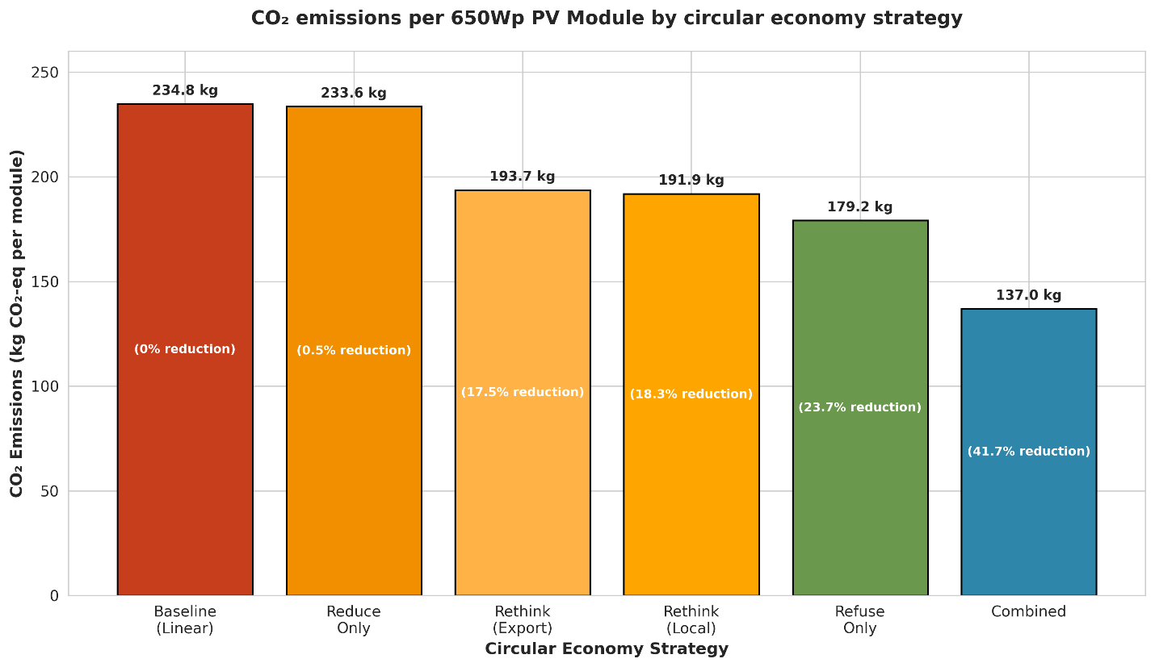
Figure 1: CO₂ emissions per 650Wp PV Module by circular economy strategy

The baseline scenario with no CE intervention emits 234.8 Kg CO₂-eq/ module. When individual CE interventions were applied, it led to the reduction of emissions to varying degrees:
- Reduce only (installation + O&M efficiency) has minimal impact: 233.6 Kg CO₂-eq (0.5% reduction). This was expected because installation and O&M together contribute only 2.0% of the total baseline emissions.
- Rethink (Export recycling) lowers the emissions to 193.7 Kg CO₂-eq, a reduction of 17.5%. Benefits come from the avoided emissions during material recovery processes.
- Rethink (Local recycling) is slightly better as it lowers the emissions to 191.9 Kg CO₂-eq which is 18.3% reduction due to the larger offset (-42.90 Kg) from avoided international transport.
- Refuse only (25% reduction in manufacturing emissions) achieves 179.2 Kg CO₂-eq, a 23.7% reduction. Targeting the manufacturing hotspots through procurement yields the highest single strategy impact.
- Combined Scenarios (refuse + reduce + export recycling) offers lowest emissions of 137.0 Kg CO₂-eq, a 41.7% reduction relative to baseline emissions. This demonstrates that integrating all three principles produces a synergistic effect.
National Emissions Projections (by 2050)
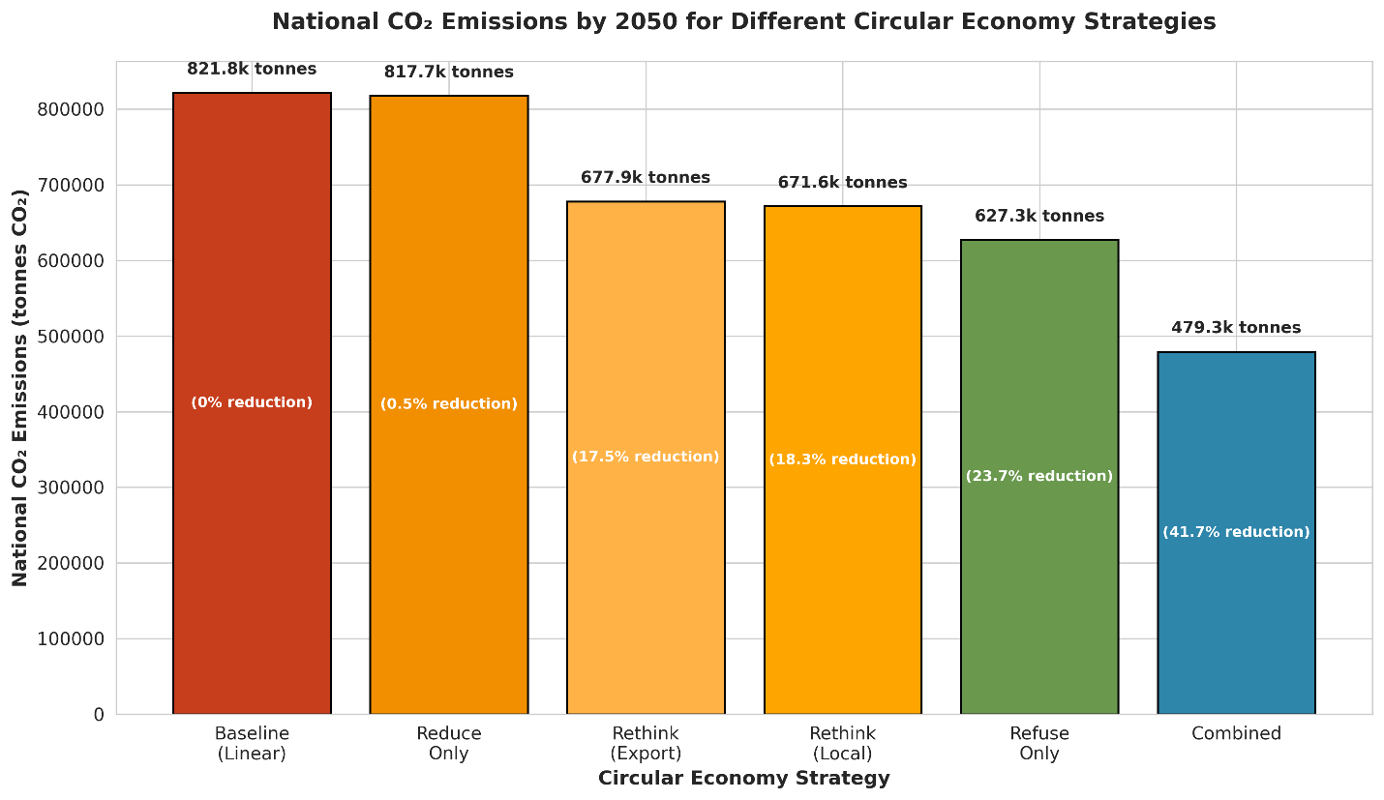
Figure 2: National CO₂ Emissions by 2050 for Different Circular Economy Strategies
Using the projected cumulative number of end-of-life modules in Kenya by 2050, 3.5 million units which is an equivalent of approximately 42,000 tonnes of solar PV waste, were scaled to national totals. The baseline national emissions reach 821,779 tonnes of CO₂. The combined scenario avoids 342,449 tonnes of CO₂ by 2050.
Economic Viability of Circular Economy Strategies
Using the economic parameters and discounted cash flow equations (Equations 7-12), Table 7 presents the economic indicators per module for each scenario.
Scenario | NPV (USD/Module) | IRR(%) | BCR | PI | DPP (years)
Baseline (Landfill) | -$1.85 | N/A | 0.82 | 0.82 | Never
Refuse only | -(cost avoidance) | N/A | N/A | N/A | immediate
Reduce only | +$3.50 | 19% | 1.52 | 1.52 | 1.5
Rethink (Export recycling) | -$2.80 | N/A | 0.88 | 0.88 | N/A
Rethink (Local recycling) | -$0.50 | N/A | 0.96 | 0.96 | N/A
Combined | +$1.20 | 18% | 1.07 | 1.07 | 4.5
Table 4: Economic Viability Assessment

All values are in US Dollars ($), using an exchange rate of 129.52 KES/USD from the Central Bank of Kenya and a discounted rate of 8.75% (CBK June 2026 rate). NPV calculations assumed revenues from recovered materials realized at year 5. Refuse only does not require investment as it generates savings through lower module prices; therefore, traditional NPV was not applicable. Landfill disposal costs were avoided in recycling scenarios.
Baseline (Landfill): Is economically unattractive because; it has a negative NPV (-$1.85), BCR of 0.82 (<1), PI of 0.82 (<1), and never reaches payback.
Refuse only: It is not a typical investment because: it is a cost avoidance strategy with an immediate payback as there in no upfront capital outlay required.
Reduce only: It is a financially attractive individual strategy. Positive NPV (+$3.50), IRR of 19% (exceeds the 8.75`% discount rate), BCR of 1.52, PI of 1.52, and a quick 1.5-year payback.
Rethink (Export recycling): Not economically viable. It shows a negative NPV (-$2.80), BCR of 0.88 (<1), and no payback period is achieved. International transport costs make it financially unfeasible.
Rethink (Local recycling): Not viable although it’s better than recycling (export). It has a negative NPV (-$0.50), BCR of 0.96 (<1), and no DPP. It is marginally below the break-even point.
Combined: It is viable and synergistic. Has a positive NPV (+$1.20), IRR of 18%, BCR of 1.07 (>1), PI of 1.07 (>1), and a discounted payback of 4.5 years. While the financial returns are moderate, it delivers the highest emission reduction (41.7%).
Conclusion
Solar PV manufacturing is the dominant carbon hotspot for Kenya’s renewable energy sector, representing 94.68% of the total lifecycle footprint. Because this embodied carbon is effectively locked in at the point of importation, the study advocates for a strategic transition toward a regenerative energy model guided by the Refuse, Reduce, and Rethink principles. The Refuse strategy implemented through green procurement, emerged as the most potent mitigation lever with a 23.7% reduction potential. Furthermore, while Reduce strategies offer immediate operational gains, the Rethink principle proved transformative by demonstrating that a formal recycling pathway generates a carbon offset fifty times greater than the emissions associated with current landfill practices. Quantitative simulations confirm that a combined circular framework is both environmentally impactful and economically superior, with the potential to reduce national emissions by 41.7% by 2050. This avoids approximately 342,449 tonnes of CO₂, equivalent to removing 72,000 vehicles from Kenyan roads annually. Economically, the framework yielded a highly attractive Internal Rate of Return (IRR) of 18% and a Benefit –Cost Ratio (BCR) of 1.07, with local recycling infrastructure projected to achieve profitability within 0.96 years. Ultimately, by integrating these findings into national policy, Kenya can transition from a passive consumer of imported technology to a proactive leader in regenerative systems, providing a replicable roadmap for other developing nations to achieve a resilient, low-carbon future.
Future Work
Empirical validation of the proposed framework through cross-sector stakeholder engagement will be done along with a detailed techno-economic feasibility studies for local recycling infrastructure to ensure the practical scalability of these circular economy strategies within Kenya’s evolving energy landscape.
Acknowledgement
This work was supported by the Multimedia University of Kenya through my research supervisors Dr. D. W. Wekesa, Dr. A. M. Marucha.

References
- Intergovernmental Panel on Climate Change (IPCC), Climate Change 2022: Mitigation of Climate Change. Contribution of Working Group III to the Sixth Assessment Report of the Intergovernmental Panel on Climate Change. Cambridge University Press, 2022. doi: 10.1017/9781009157926.
- International Energy Agency (IEA), “The world is on course for a record 78 million tonnes of solar panel waste by 2050”, IEA Commentary, 2023. [Online]. Available: https://www.iea.org/commentaries
- Hosseini, S. M., Paydar, M. M., & Hajiaghaei-Keshteli, M. “Decision-Making Approach to Design a Sustainable Photovoltaic Closed-Loop Supply Chain Considering Market Share for Electric Vehicle Energy. Sustainability”, 16(13), 5763, 2024, doi:10.3390/su16135763.
- Infologic Group, “A market intelligence report on East Africa’s solar PV and e-waste sector”, Infologic Group, Nairobi, Kenya, 2025.
- N. A. Ludin, N. I. Mustafa, M. M. Hanafiah, M. A. Ibrahim, M. A. Mat Teridi, S. Sepeai, A. Zaharim, and K. Sopian, "Prospects of life cycle assessment of renewable energy from solar photovoltaic technologies: A review," Renew. Sustain. Energy Rev., vol. 96, pp. 11–28, Nov. 2018, doi: 10.1016/j.rser.2018.07.048.
- International Renewable Energy Agency (IRENA), Renewable energy statistics 2023, IRENA, Abu Dhabi, 2023. [Online]. Available: https://www.irena.org/publications
- Ellen MacArthur Foundation, "Completing the picture: How the circular economy tackles climate change," Ellen MacArthur Foundation, 2019. [Online]. Available: https://www.ellenmacarthurfoundation.org/publications
- J. Kirchherr, D. Reike, and M. Hekkert, "Conceptualizing the circular economy: An analysis of 114 definitions," Resour. Conserv. Recycl., vol. 127, pp. 221–232, Dec. 2017, doi: 10.1016/j.resconrec.2017.09.005.
- L. Wang, L. Oberbeck, M. M. Lasserre, and P. Pérez-López, "Modelling recycling for the life cycle assessment of perovskite/silicon tandem modules," EPJ Photovoltaics, vol. 15, p. 14, 2024, doi: 10.1051/epjpv/2024010.
- G. Heath, D. Ravikumar, B. Hansen, and E. Kupets, "A critical review of the circular economy for lithium-ion batteries and photovoltaic modules – status, challenges, and opportunities," J. Air Waste Manage. Assoc., vol. 72, no. 6, pp. 478–499, 2022, doi: 10.1080/10962247.2022.2068878.
- Climate.Co. Ke, “The state of solar energy and circular economy in Kenya”, Climate News Kenya, 2025. [Online]. Available: https://climate.co.ke
- S. Khalifa, B. V. Mastrorocco, D. D. Au, S. Ovaitt, T. M. Barnes, A. Carpenter, and J. B. Baxter, "Dynamic material flow analysis of silicon photovoltaic modules to support a circular economy transition," Prog. Photovolt.: Res. Appl., vol. 30, no. 8, pp. 938–954, 2022, doi: 10.1002/pip.3554.
- N. Mukisa, R. Zamora, T. T. Lie, X. Wu, and G. Chen, "Viability of the store-on grid scheme model for grid-tied rooftop solar photovoltaic systems in Sub-Saharan Africa," J. Clean. Prod., vol. 280, p. 124428, Jan. 2021, doi: 10.1016/j.jclepro.2020.124428.
- T. Olang, P. Okoth, and G. Ochieng, "Solar photovoltaic waste management in Kenya: Challenges and opportunities for circular economy adoption," Energy Policy, vol. 162, p. 112774, Mar. 2022, doi: 10.1016/j.enpol.2022.112774.
- A. Gichangi, J. Mutua, and R. Ochieng, "Solar photovoltaic deployment and sustainability challenges in Kenya," Renew. Energy Focus, vol. 38, pp. 54–62, Sep. 2021, doi: 10.1016/j.ref.2021.06.002.
- Energy and Petroleum Regulatory Authority (EPRA). Energy and Petroleum Statistics Report: June 2025. Nairobi: Government of Kenya.
- International Energy Agency (IEA). (2025). Energy Policy Review of Kenya 2025. Paris: IEA Publications.

